

TLD Website

User’s Guide

© TLD 2006

Table of Contents

1
TLD Website 1
User’s Guide 1
© TLD 2006 1
Table of Contents 1
Introduction 4
Standard Forms, Reports and Nomenclature 4
Table View 4
Columnar Report 5
Multi Level Report 6
Language Codes 6
ERP Company Numbers 6
TLD Intranet Homepage 8
My Account Module 9
Edit Page 9
Change Password Form 10
Change Photo Form 10
Groups Page 11
Calendar Module 12
Tasks Section 12
Events Section 17
Directory Module 17
Directories 17
Departments Page 19
Org Chart Page 19
Search Form 20
Locations Page 21
Netmeeting Page 21
Corporate Module 22
TLD Direct Page 22
Internal News Section 23
Sales Module 23
Catalogue Section 24
Equipment Profile Section 27
ODP Page 27
Inventory 28
GSE/Aircraft Data Section 28
Competition Page 29
Sales Order Process 29
Sales Order Records (SOR) 30
Sales Order Record Lines (SOR Lines) 34
Equipment Shipping Records (ESR) 37
Parts Sales Module 39
Research Page 40
Inventory Page 41
Cart Section 41
Service Module 42
Service Records Section 42
Product Support Module 43
PDC Section 44
Equipment Section 45
Warranty Section 46
Service Bulletins Section 48
Publications Module 49
Old Service Module 52
Manufacturing Module 53
QA Module 53
Engineering Module 57
Purchasing Module 59
Manufacturing Reports 66
MIS Module 66
Trouble Ticket System (TTS) 66
Inventory 67
Table of Figures 1

Introduction

Standard Forms, Reports and Nomenclature
Whenever possible, standard forms and reports are used throughout the TLD Website in order to maintain a consistent interface and user experience. We list here the most common forms and reports and describe how to use them. Whenever you see a standard form or report usage will be similar no matter what module it is in or what data it contains. By learning how to operate these standard forms and reports you will be able to quickly learn to get the most out of YOUR website.

Table View
- The screenshot below shows a typical example of a Table View.
- There is a menu at the top of the page.
  - The Add menu item only appears if you have the correct authorizations for the table view.
  - Detailed Search allows you to narrow a search in the database by specifying stricter criteria.
  - The Reset link returns the table view to the default view of all records and removes any criteria that may be set by a Detailed Search.
  - The Download link provides a means of downloading all the records, in the current record set, as a Comma Separated Text file.
  - List All will show all records in the current record set on a single page.
- Two separate forms below the menu:
  - Sort form, allows you to sort the current record set by one single field and in ascending or descending order.
  - Find form allows you to do a quick search for a string.
  - HINT: Each field in the database will be searched for matches so searching for ‘closed’ will not necessarily find only records with a status of closed since the word ‘closed’ may appear in a field other than a status field.
- Below this is a position indictor which shows the current record number and the total number of records in the current record set.
- Surrounding the position indicator are navigation arrows. Using these arrows you can move through the records page by page or jump to the beginning or end of the current record set.
- HINT: If you are paging through many pages looking for a record, you should consider doing a Find or a Detailed Search.
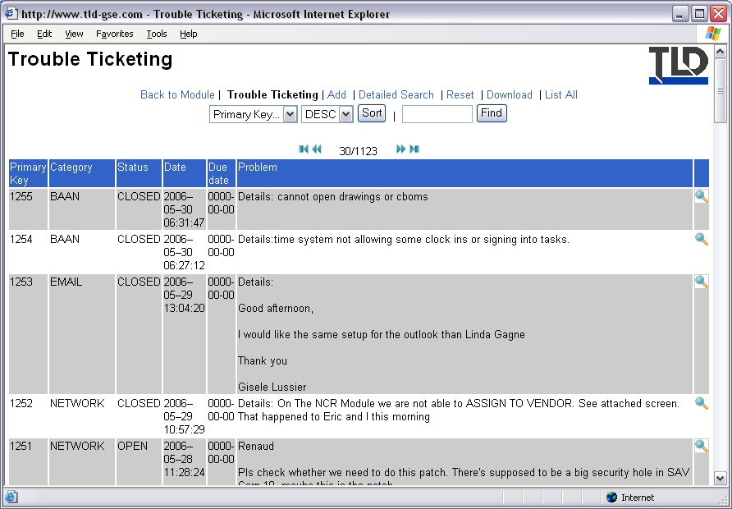
Figure 1, Example Table View

Columnar Report
- A columnar report is consists of rows and columns of data.
- The top of a columnar report usually shows the reports title followed by column headings.
- Each subsequent row then contains individual records.
- Each column contains data for particular fields.
- Each cell in a row contains the information of a field for the corresponding record.
- Links can be present in any of the fields.
- HINT: If a link is present, the data within a field will appear in blue.
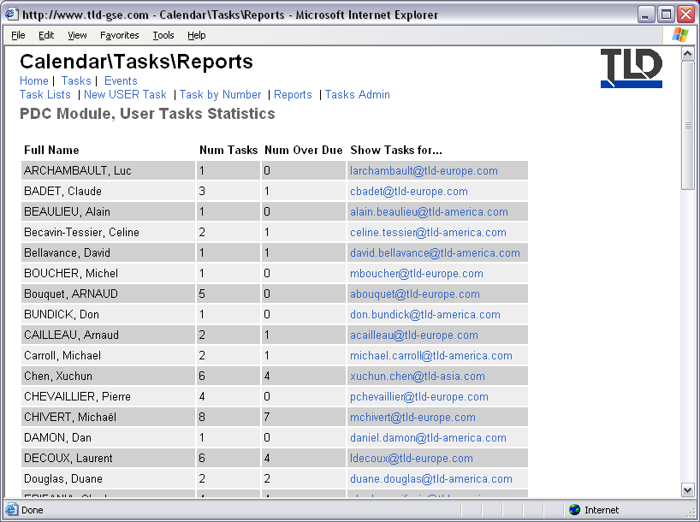
Figure 2, Example Columnar Report

Multi Level Report
- A Multi Level Report is similar to a columnar report except that records are grouped according to one or more fields.
- The example below shows a report of tasks grouped by Assignee and then Task Type.
- You can jump to different first levels by select a level from the drop down box below the title.
- To view a particular record, click on the magnifying glass on the left of the required record.
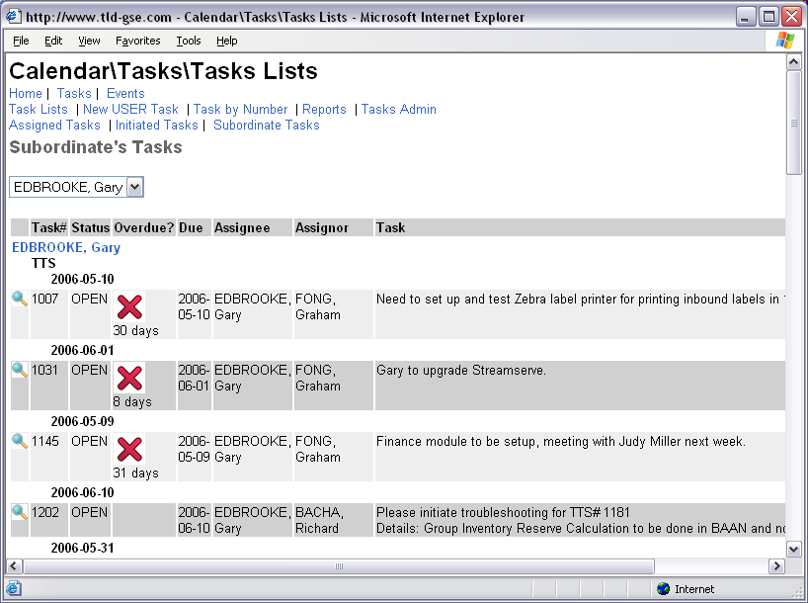
Figure 3, Example Multi Level Report

Language Codes
Throughout the website we use ISO 639-1 standard of language codes. Current languages supported by our website are listed below.
Code | Language Name
EN | English
FR | French
DE | German
PT | Portuguese
ZH | Chinese
JA | Japanese

ERP Company Numbers
Throughout the website we use a system of codes to represent the ERP system that a TLD entity uses. The current codes are given in the table below. The active list of codes are available from the Locations section of the website. For more details, please refer to the chapter describing the Locations section, later in this guide.

ERP | Entity Name
300 | TLD America
400 | TLD Windsor
420 | TLD Canada
500 | TLD Montlouis
520 | TLD St. Lin
600 | TLD Hong Kong
620 | TLD Shanghai

TLD Intranet Homepage
Once logged into the TLD Intranet you arrive at the homepage.
- At the top of the page, where the TLD logo is situated, is the main menu.
- This menu will remain visible where ever you are located throughout the Intranet.
- You will use this menu to navigate the Intranet from module to module.
- For the purposes of easily defining terms used in this guide, we define parts of the website in order of complexity.
  - A ‘Module’ has multiple links to ‘Sections’ allowing different but related operations to be performed.
  - Sections contain one or more related ‘Pages’ of information or forms.
  - For example, the Calendar Module has two sections: Tasks and Events. Within the Tasks section there are several pages including Tasks Lists, New Task and Task by Number. Tasks Lists requires no user input and is therefore an ‘Informational page’ whereas the New Task page requires user input and is generally referred to as a ‘Form’.
- The rest of this document describes each module and section in greater detail and provides hints to get the most out of YOUR intranet.
- HINT: To get back to the TLD Intranet Homepage, hit the HOME link at the very left of the menu bar.
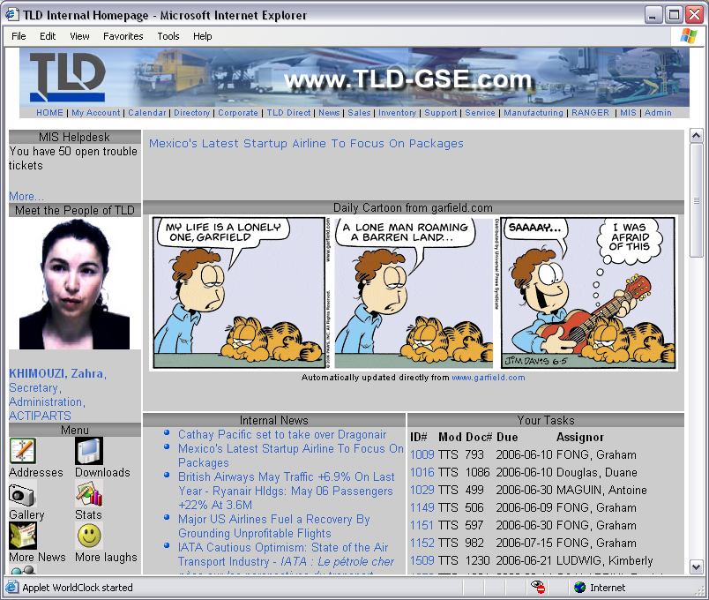
Figure 4, TLD Intranet Homepage

My Account Module
- The first module on the menu is the My Account Module. This module contains related information regarding your website account and provides forms for editing some of the information listed in your account.
- The homepage shows your picture, if you have previously uploaded one , on the left with details on the right.
- This view is usually referred to as your ‘vCard’.
- HINT: You can download a copy of your vCard and save it to your computer. You can then email this to others so they can import your information directly into any vCard capable software without having to retype your information.
- HINT: This is true for any vCard that you see in the Intranet. You can therefore find others in the TLD Directory (see later) and download their vCard directly into a vCard aware application such as Outlook without having to retype anything.
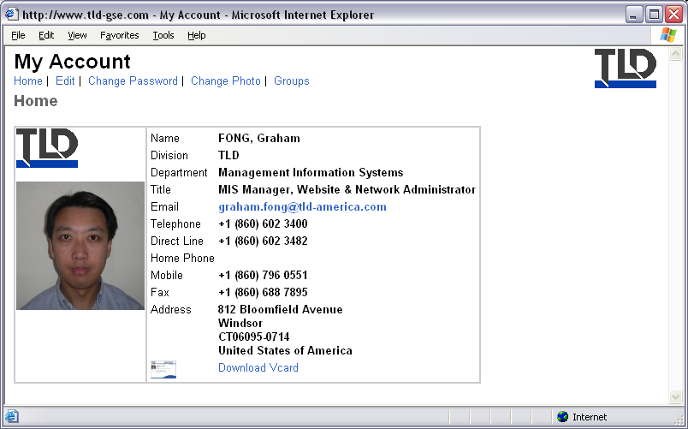
Figure 5, My Account Homepage

Edit Page
- The first menu item is the Edit form.
- From this form you can review your information and update it.
- After making your modifications, hit the Submit button to save the changes.
- HINT: You cannot change your email address from this screen because your email address is used as your username to enter the Intranet. Only the Webmaster or authorized Human Resources personnel can change the email address for you.
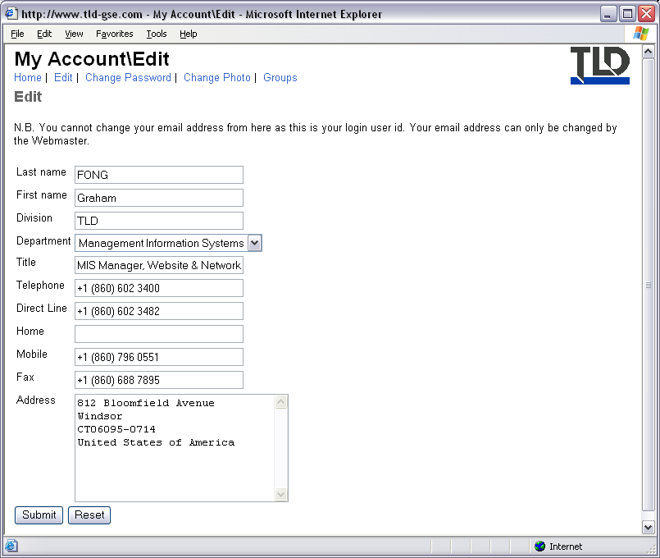
Figure 6, Account Edit Form

Change Password Form
- Using the Change Password form you can change your password to a new one.
- You MUST enter your current password in the first field then enter your chosen new password into both of the following fields.
- If the old password is incorrect, the password change will fail.
- HINT: If you have saved your password into your browser, and forgotten what it is, you can retrieve the password by hitting the link “If you have forgotten your password, click here to have it emailed to you.” You will be taken to a form asking for your email address. Once you have completed the form and submitted it, you should receive an email containing your password.
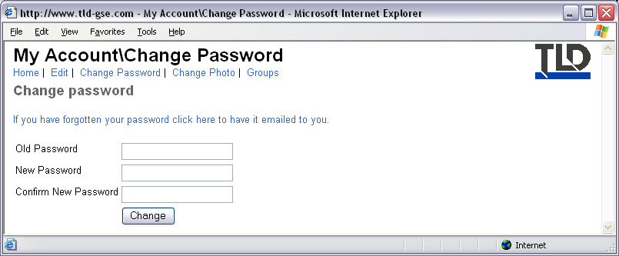
Figure 7, Change Password Form

Change Photo Form
- This page contains two forms: Upload Photo and Delete Photo.
- The Upload Photo form allows you to upload a picture of yourself that will appear on your vCard and in the TLD Directory.
- Hit the Browse button then, in the dialog box that appears, navigate to and select the picture you want to upload. Once selected, hit the Upload button to begin the upload operation.
- HINT: Once your picture has been uploaded it will be automatically resized. If the proportions of your picture are not square then the picture may become distorted during the transformation process.
- For best results, your picture should be square and show only head and shoulders.
- The Delete Photo form allows you to delete the existing picture if you wish.
- Select the YES radio button then hit the Delete button.
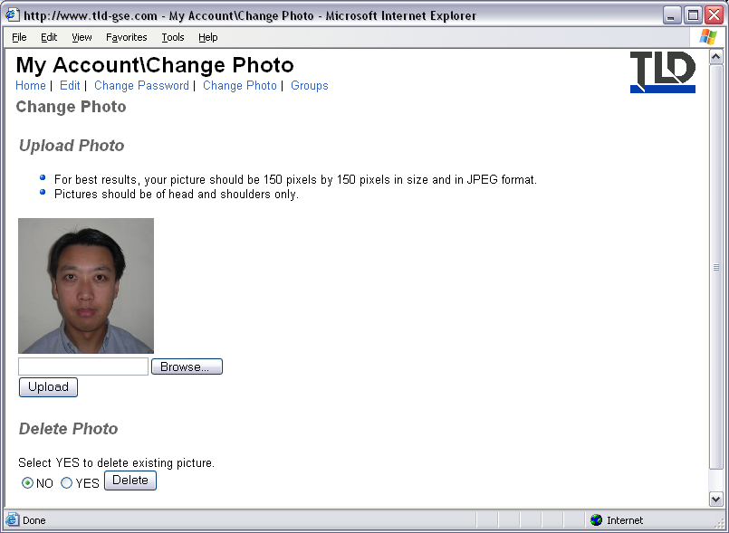
Figure 8, Change Photo Form

Groups Page
- The Groups informational page lists all the groups that your website account is associated with.
- The first column shows the Group Name.
- The second column shows the level or ERP system code, depending on the usage for the group.
- The last column provides a brief description of the group.
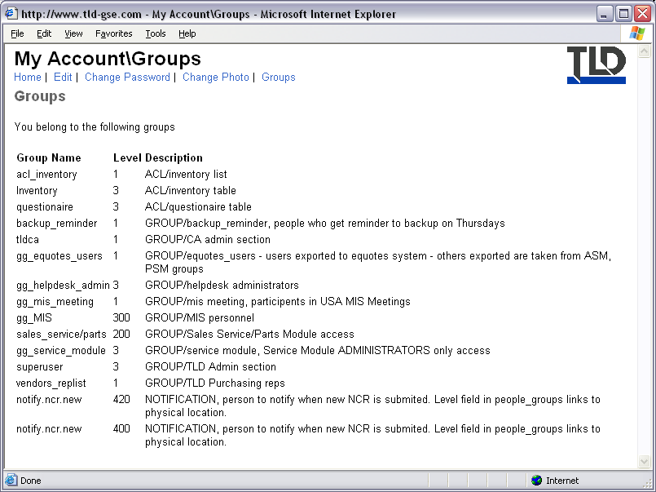
Figure 9, Groups Page

Calendar Module
The Calendar module contains two sections: The Tasks and Events sections.

Tasks Section

Task Lists Page
- The Task Lists page of the Tasks Module allows you to view all currently OPEN:
  - Tasks that have been assigned to you
  - Tasks that you have initiated for others
  - And tasks that have been assigned to all of your subordinates.
- Each Task List is grouped by the type of task. To quickly jump to a particular task type, use the drop down box just below the menu.
- The standard Multilevel Report is used to display Task Lists. Instructions for using this type of report are given in the Standard Forms, Reports and Nomenclature section of this guide.
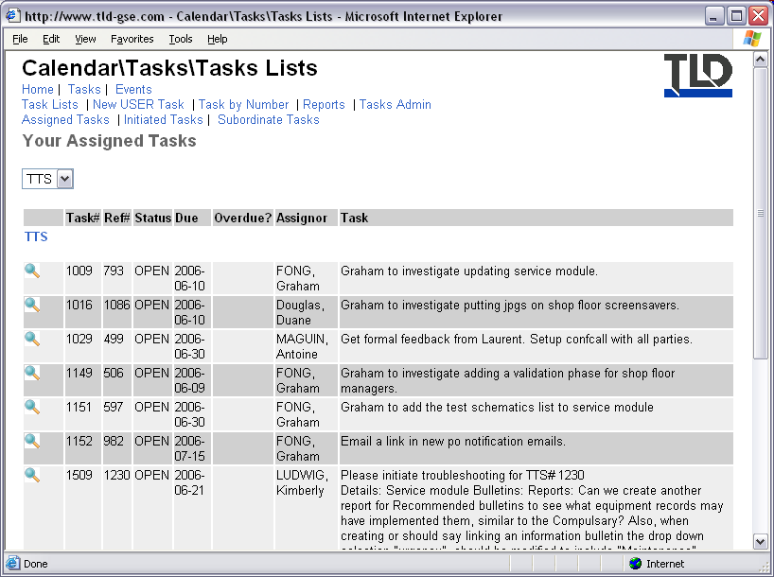
Figure 10, Tasks Lists Homepage

Task
- There are several types of tasks; the task type depends on the module that the task is linked to.
- Task types include PDC, NCR, CPA and USER.
- An example task is given below.
- At the top of the page is the Task menu with the following items:
- View Task
  - Shows the task header details plus all associated comments below it.
  - If the task is linked to a module, the type and reference number will be shown next to the Module label with a link to the associated document. In the example below, the tasks is linked to a Trouble Ticket system document numbered 793.
  - The full names of the Assignor and Assignee are given in the task header with links to the individual’s vCard.
  - HINT: If you are viewing multiple tasks then Prev and Next links will appear just above the header. Use these links to quickly navigate through the current record set.
  - In between these links there is a position indicator showing the number of the current task being viewed and the total number of tasks in the current record set.
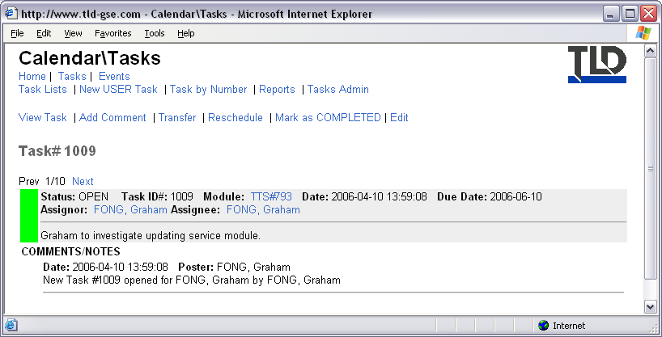
Figure 11, Example of a Task
- Add Comment
  - The Add Comment Form allows you to post comments related to the task.
  - You can also upload a file.
    - To upload a file, hit the Browse button
    - In the dialog window that appears, navigate to the file you want to upload and select it.
    - In the Comment field, provide a description of the file.
    - Hit the Submit button to begin the upload process.
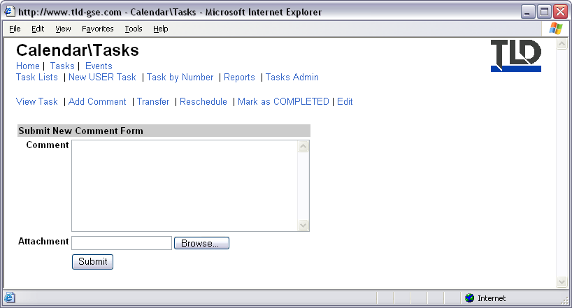
Figure 12, Add Comment Form
- Transfer
  - If you think that the task cannot be completed by you and that somebody else is more suited then you can transfer the task using the Transfer Task Form.
  - In the Assignee drop down box, select the person you want to transfer the task to.
  - Provide a reason for the transfer in the box below.
  - Hit the Submit button to process the transfer request.
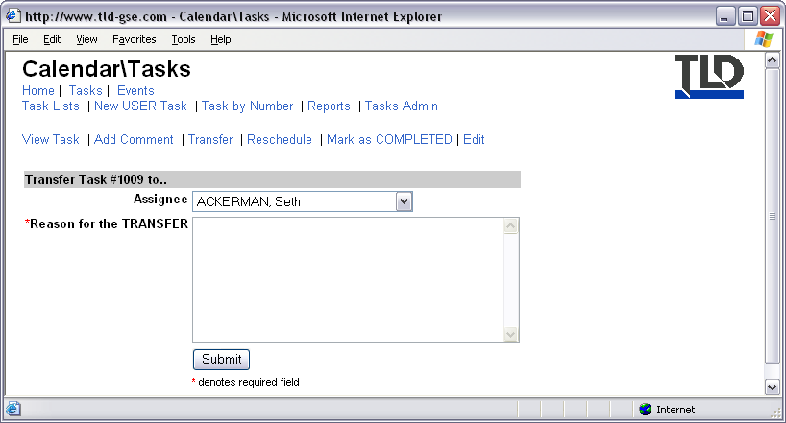
Figure 13, Transfer Task Form
- Reschedule
  - If you cannot complete a task by the given Due Date then you can reschedule the task using the Reschedule Form.
  - Using the drop down boxes, select the date you want to reschedule the due date for the task to.
  - In the field below the date, provide an explanation why you are rescheduling the task. This is a required field.
  - Hit the Submit button to process the reschedule request.
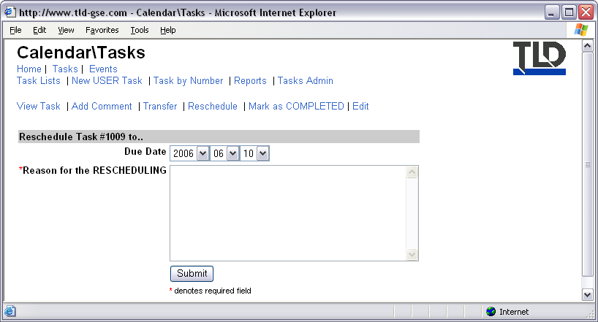
Figure 14, Reschedule Task Form
- Mark as COMPLETED
  - When a task has been completed use the Mark as Completed function to close the task.
  - You will be presented with a confirmation page, before the task is actually closed, to help prevent inadvertently closing tasks.
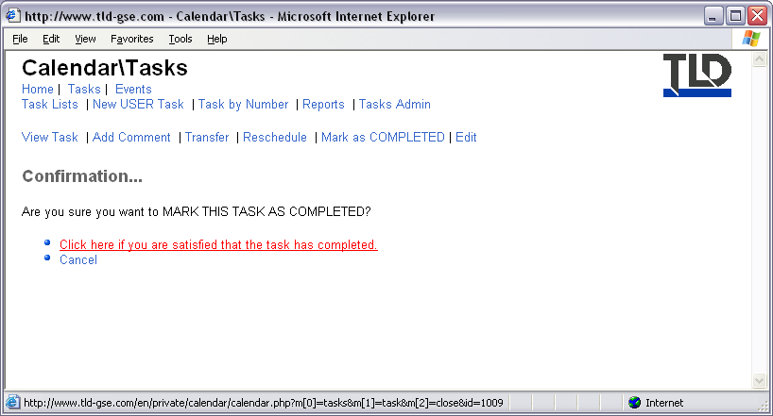
Figure 15, Mark as Completed confirmation page
- Edit
  - The Edit function is only allowed for authorized personnel.

New User Task Form
- The only task type that is not linked to a module is a User task.
- User tasks can only be created using the New User Task link in the Tasks
  - A User task is a task created between individuals.
  - HINT: You can only create a USER task for
    - your subordinates
    - your direct manager
    - or others who also report to the same manager as you
  - Who you can create a task for is determined using the relationships contained in the TLD Directory. If you cannot select a particular user to create a User task for then you should contact your local HR manager or the Webmaster and ask them to check the ‘Supervisor’ field in your account.

Task by Number Form
- If you know the reference number of a Task, you can access it directly using this form.
- Enter the number in the empty field then hit the Submit button.

Reports Page
- The Reports Page lists any available related reports that can be generated.

Tasks Admin Page
- Admin pages are only available to authorized personnel.
- HINT: There may be links shown in screenshots that you would not normally have because your account does not have the required privileges.

Events Section
- The Events section lists holidays and upcoming events related to TLD.
- To view all events for the current year, on one page, hit the ‘Current Year’ link.
- To view events within a particular month only, hit the corresponding link with the name of the month you want to view events for.
- If you have authorization to modify the events database, you will see the Edit Holidays link.
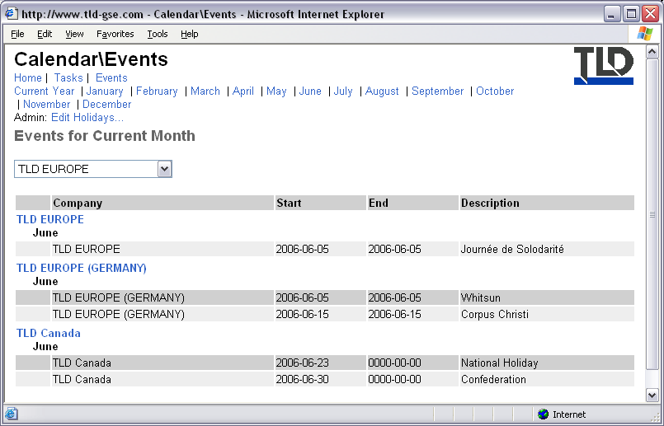
Figure 16, Events Homepage

Directory Module

Directories
The Directory Module contains all information regarding personnel and locations.
The homepage provides five icons for quickly listing personnel related to the five TLD entities shown.
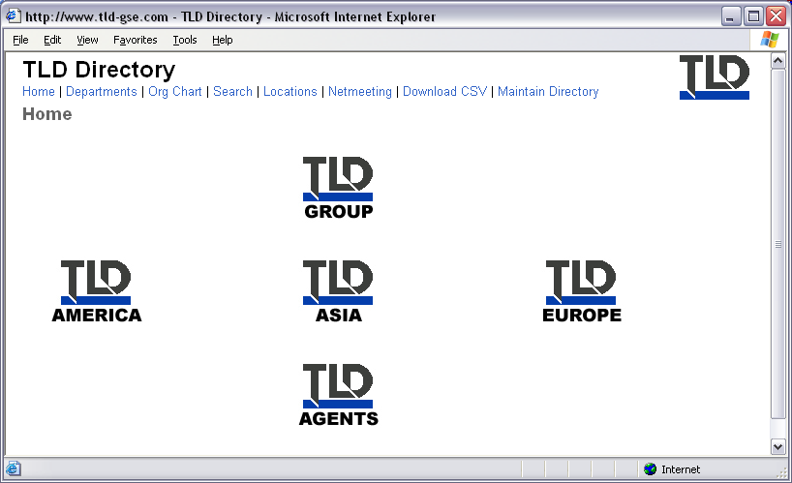
Figure 17, TLD Directory Homepage
- Clicking on one of the icons will provide a list of all personnel within the selected entity.
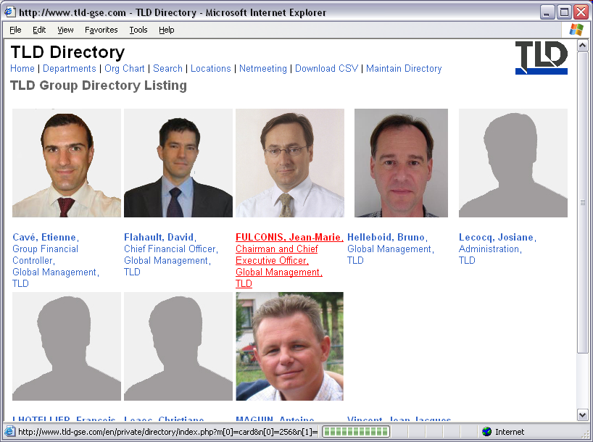
Figure 18, Example Directory Listing
- By clicking on an individual’s picture you will be presented with that person’s vCard.
- HINT: To quickly add a user’s contact details into a vCard aware software you can download the vCard by hitting the link provided at the bottom of the screen.
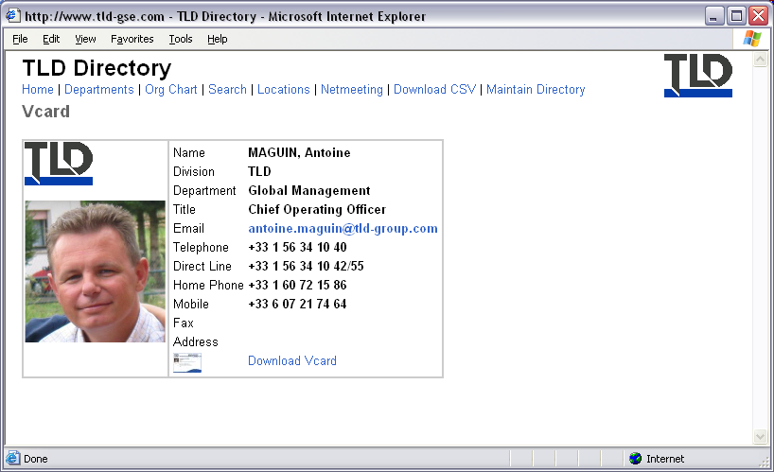
Figure 19, Example vCard

Departments Page
- The Departments page allows you to view personnel according to the department which they belong to.
- This will show departmental users group wide.
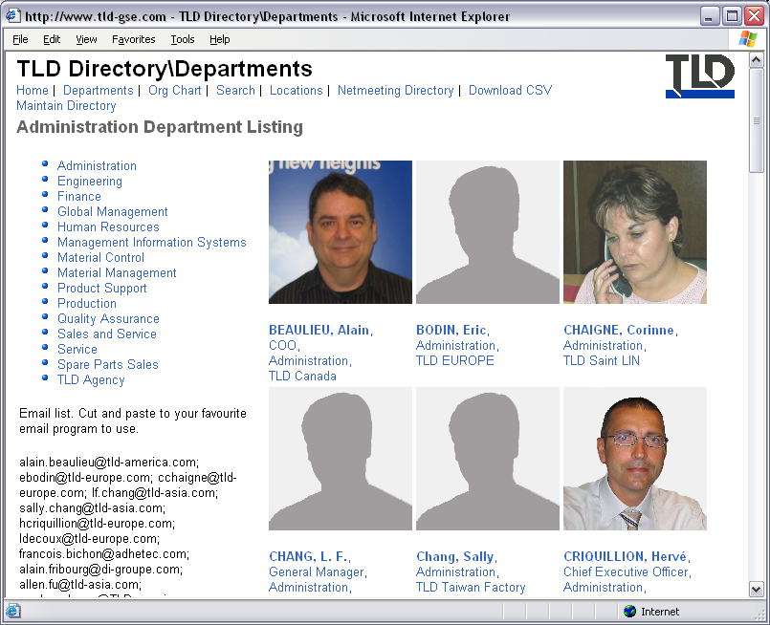
Figure 20, Departments Section

Org Chart Page
- The Org Chart page provides organization charts based on the supervisor relationships of each user’s account.
- To view an org chart for a territory, click the corresponding icon.
- HINT: Due to the number of accounts within a territory, territory org charts can take longer to create than office or business unit org charts.
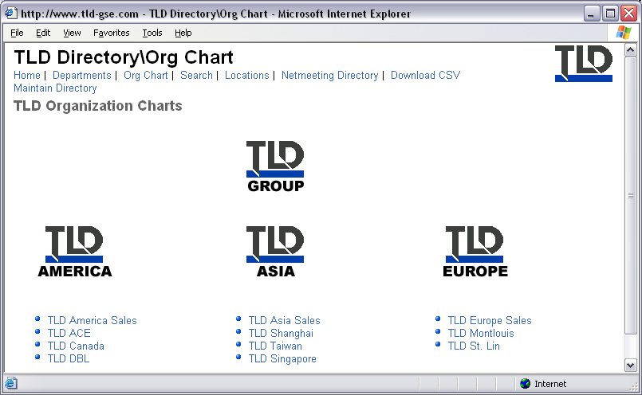
Figure 21, Organization Chart Page
- To view an org chart for an office or business unit, click the corresponding link in the list below the parent territory’s icon.
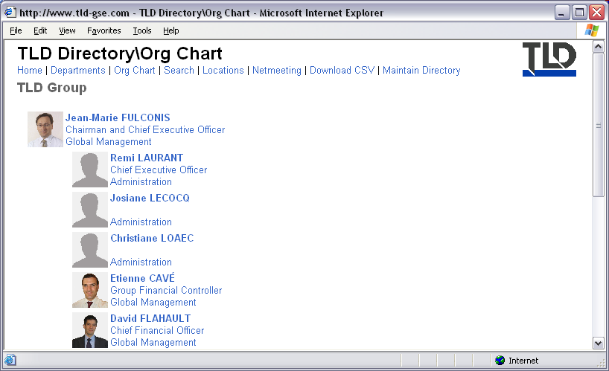
Figure 22, Example Organizational Chart

Search Form
- You can search the directory by a person’s first and last names.
- HINT: The search is a partial search e.g. to find ‘Smith’ you can type ‘smi’.
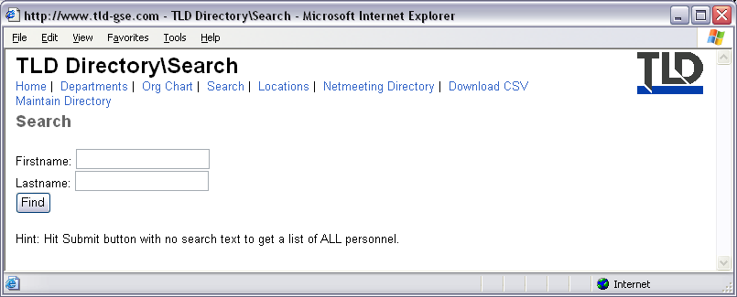
Figure 23, Directory Search Form

Locations Page
- The Locations page lists the physical locations within the group.
- HINT: There are some locations that have an ERP number. These numbers are very important and will become more prevalent throughout TLD’s information systems. You can use the Locations page to reference the corresponding location, or business unit, of an ERP number.
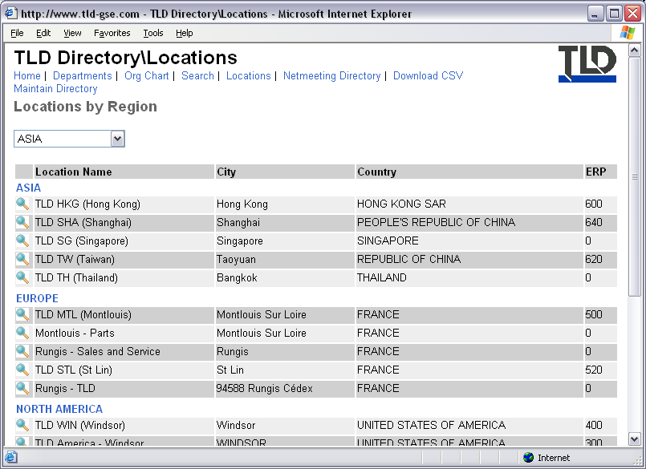
Figure 24, Locations Page
- To view detailed information regarding a location, hit the magnifying glass next to your selected location.
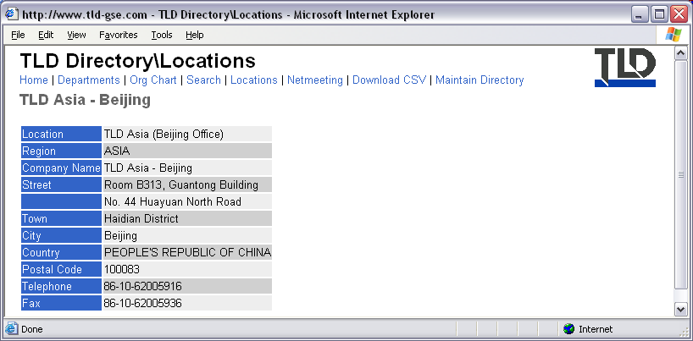
Figure 25, Example Location

Netmeeting Page
- The netmeeting page lists users that are logged into the two group wide netmeeting directories.
- If you have netmeeting installed and setup and the person you would like to call appears in the list, you can call them by clicking the Call link next to their email address in the list.
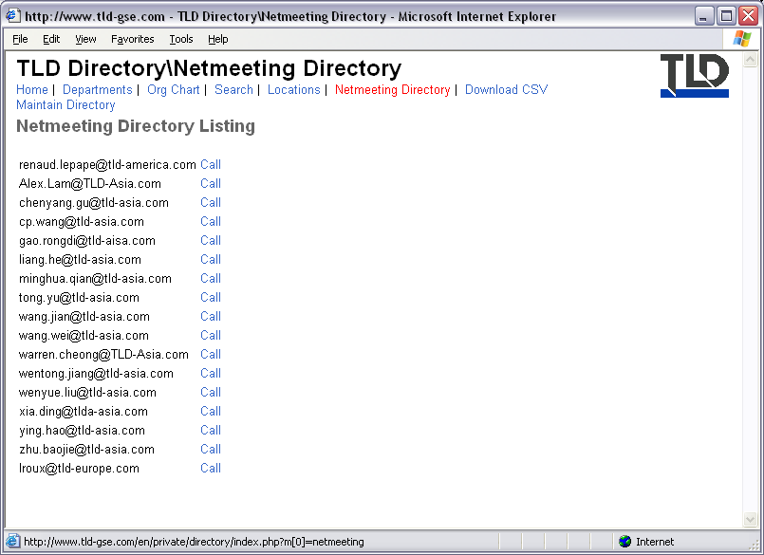
Figure 26, Netmeeting Directory

Corporate Module
- Information regarding the TLD Group is contained in the Corporate Module
- The homepage contains links to procedures and corporate identity guidelines.
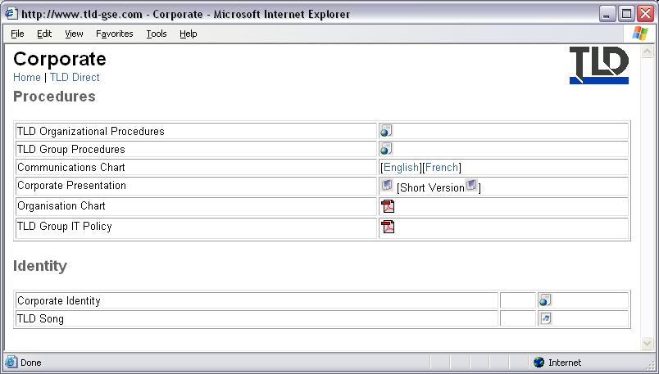
Figure 27, Corporate Homepage

TLD Direct Page
- English and French versions of the TLD Direct newsletter can be downloaded from the TLD Direct page.
- HINT: You must have Adobe Acrobat to view these documents.
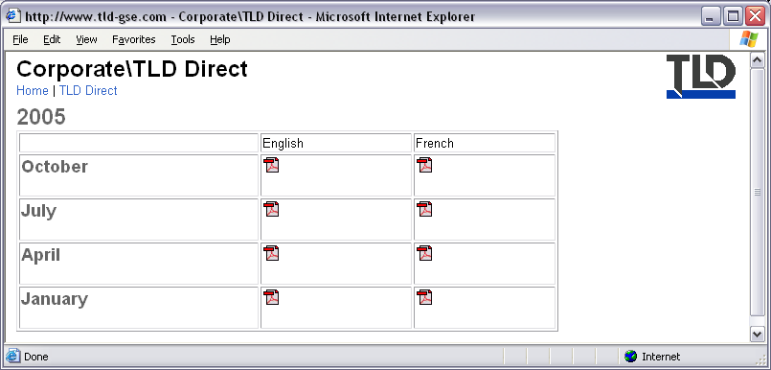
Figure 28, TLD Direct Page

Internal News Section
- The Internal News Section contains all news articles that have appeared in the Intranet.
- The Internal News Section utilizes a standard Table View report. For usage instructions please refer to the Standard Forms and Reports section of this guide.
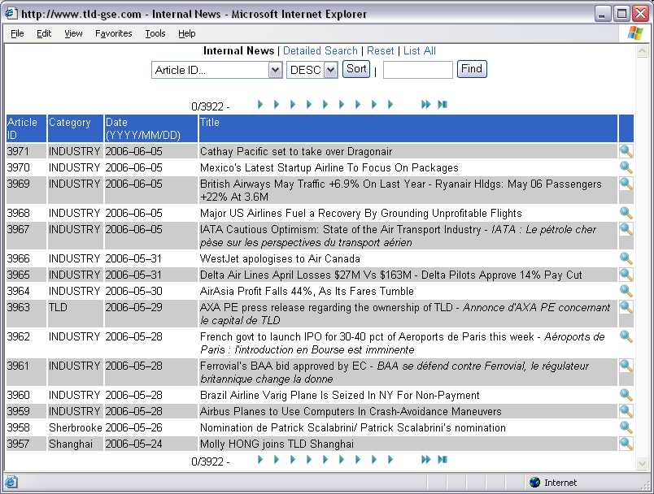
Figure 29, Internal News Table View

Sales Module
- The Sales Module contains information intended primarily for sales personnel.
- At the top of the page is a menu bar with links to the different sections available.
- The sections contained within the Sales Module are described in detail below.
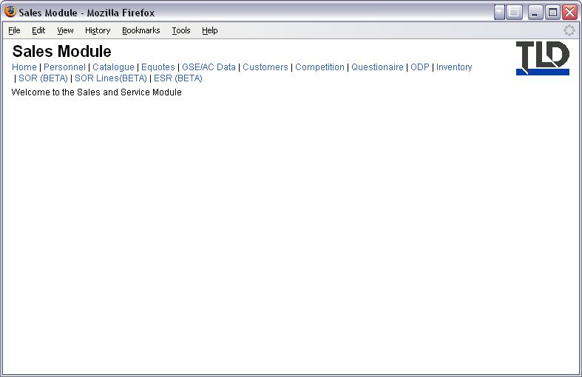
Figure 30, Sales Module Homepage

Catalogue Section
- The Catalogue section contains information regarding currently available TLD products.
- From here you can obtain sales literature such as datasheets, user lists and presentations.
- The catalogue is arranged in multi levels
- The homepage is the first level and shows a list of product types.
- To view products of a particular product type, click on the corresponding icon.
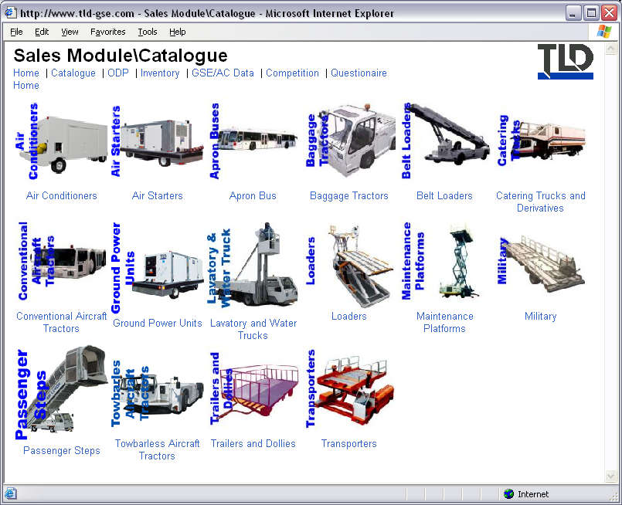
Figure 31, Catalogue Section

Product Types
- On the next page, you will be presented with icons representing the products within your chosen product type, as well as, links to User lists and Presentations.
- Clicking on a product icon will take you to the next level in the catalogue: the Equipment Profile.
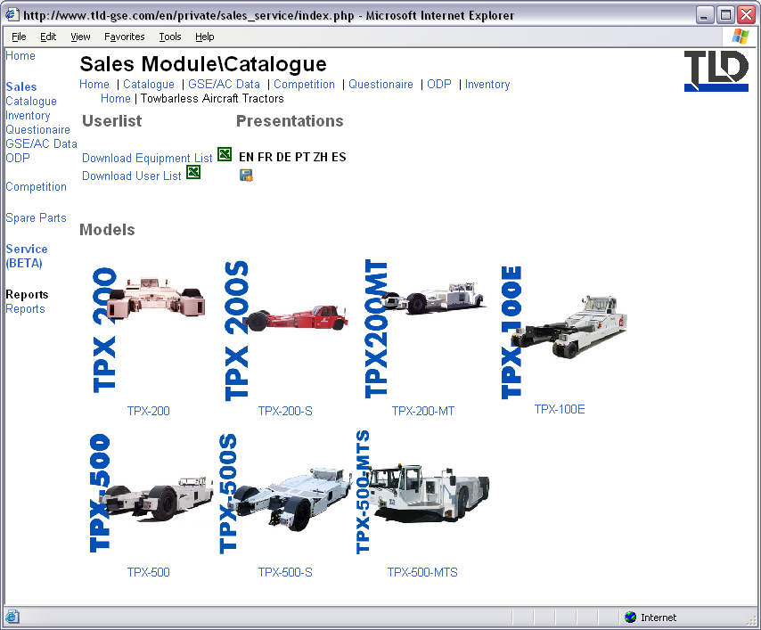
Figure 32, Example Category List

Equipment and User Lists
- Within a product type level, you can download an Equipment List or User List for the current product type.
- Equipment lists show information from the online Equipment Records system of equipment that belong to the selected product type. An example is given below.
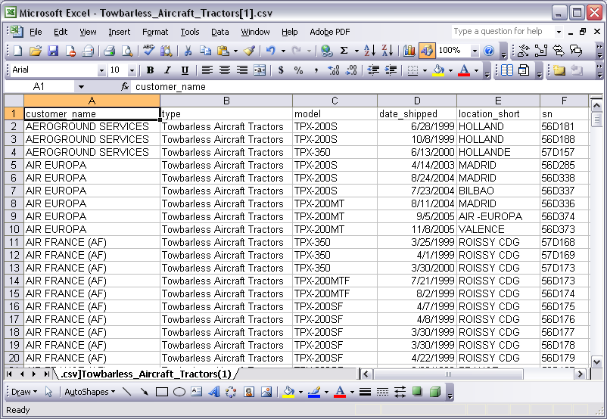
Figure 33, Example Equipment List
- User Lists show the number of equipment, of the chosen product type, that belong to a particular customer.
- An example is given below. In the example, the first line indicates that Aeroground Services has 3 pieces of equipment belonging to the Towbarless Aircraft Tractors product type.
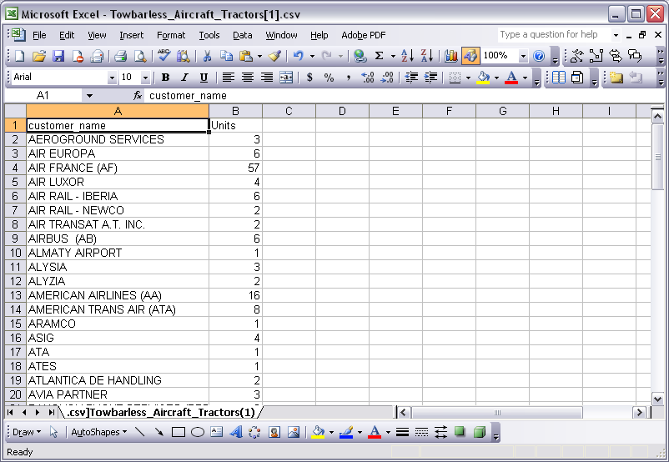
Figure 34, Example User List

Presentations
- Any available Microsoft Powerpoint presentations, pertaining to this product type, will be available for download in the area labeled Presentations.
- Presentation could be available in multiple languages.
- If a presentation is available, a floppy disk icon will appear below the corresponding language code.

Equipment Profile Section
- Once you have selected a model, the equipment profile page for the selected model will appear.
- There is a menu of links to:
  - Description: Main description of model, taken from the datasheet.
  - Revision History: Shows details of any changes made to the datasheet.
  - Datasheets & Files: You can download files related to this model from this section.
  - NTOs: This link will only appear on Towbarless Tractor profiles. From here you can download available NTOs.
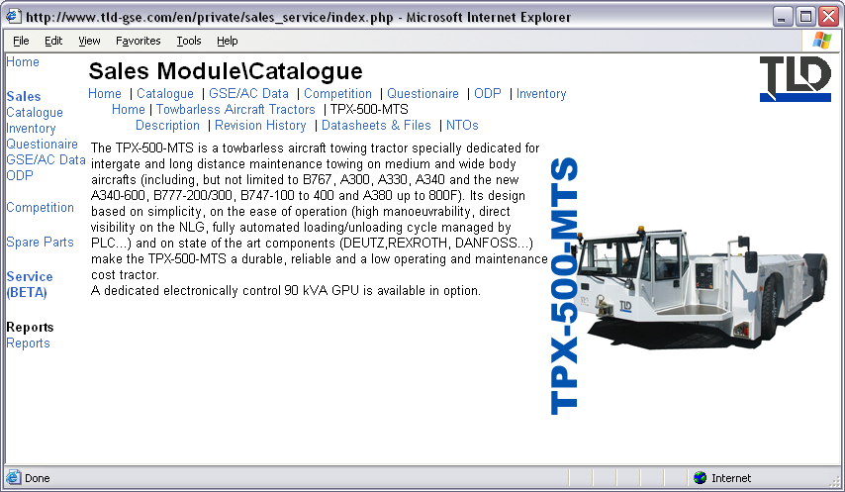
Figure 35, Example Equipment Profile

ODP Page
From the ODP page you can download factory ODP files in PDF or XLS format.
- The ODP page utilizes a standard Table View report. For usage instructions please refer to the Standard Forms and Reports section of this guide.
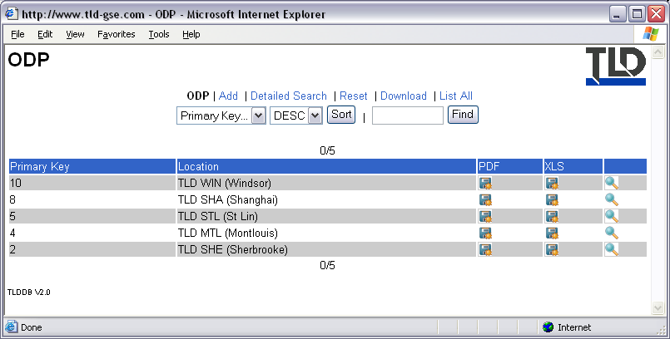
Figure 36, ODP Table View

Inventory
- The Inventory page lists units that are available for immediate sale.
- The Inventory page utilizes a standard Table View report. For usage instructions please refer to the Standard Forms and Reports section of this guide.
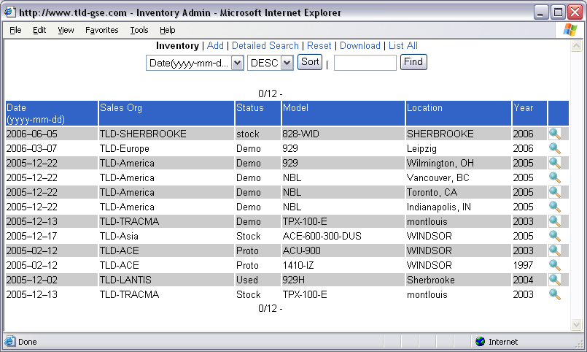
Figure 37, Inventory Table View

GSE/Aircraft Data Section
- The GSE/Aircraft Data Section contains any available information related to aircraft and/or aircraft and GSE compatibility.
- The homepage shows a matrix of available NTO/SILs available for particular aircraft and tractor combinations.
- There is a section level menu to:
  - NTO Status: This is an excel file provided by product support to show the status of pending NTOs.
  - Aircraft Compatibility: This is an excel file provided by product support that shows what aircraft that a particular aircraft tractor can handle.
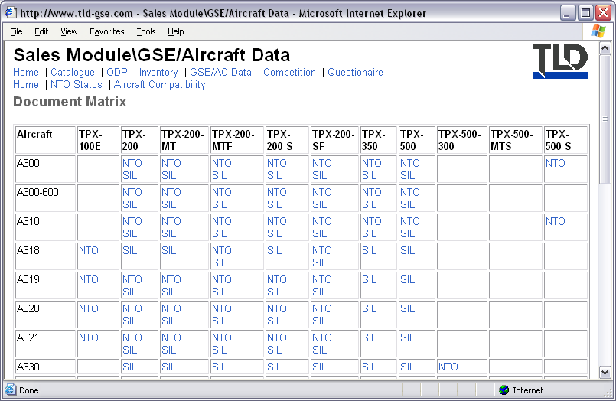
Figure 38, Document Matrix

Competition Page
This page is currently under development.
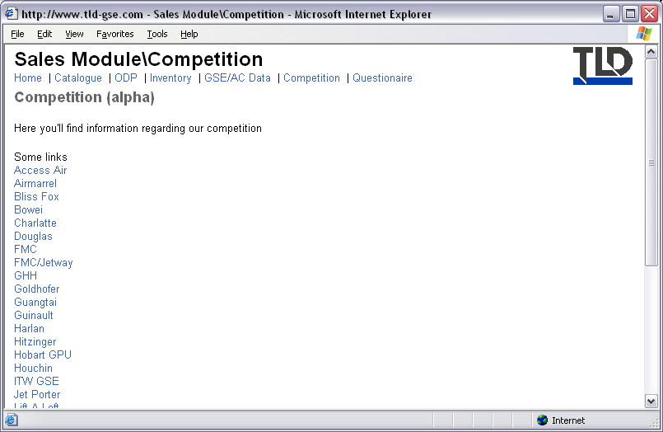
Figure 39, Competition Homepage

Sales Order Process
- Sales Order Records (SORs) are used to track the sales order process from receipt of customer’s purchase order through to payment from customer.
- The following diagram illustrates the relationship between documents used throughout the process. The whole sales order process begins with an SOR.
- For each model type required, there is a corresponding SOR Line item.
- Linked to each SOR Line item are the individual Equipment Records (ERs) that have been assigned to the SOR Line.
- For each shipment of goods there is a corresponding Equipment Shipping Record (ESR) that helps track delivery of the goods to the customer.
- You cannot create
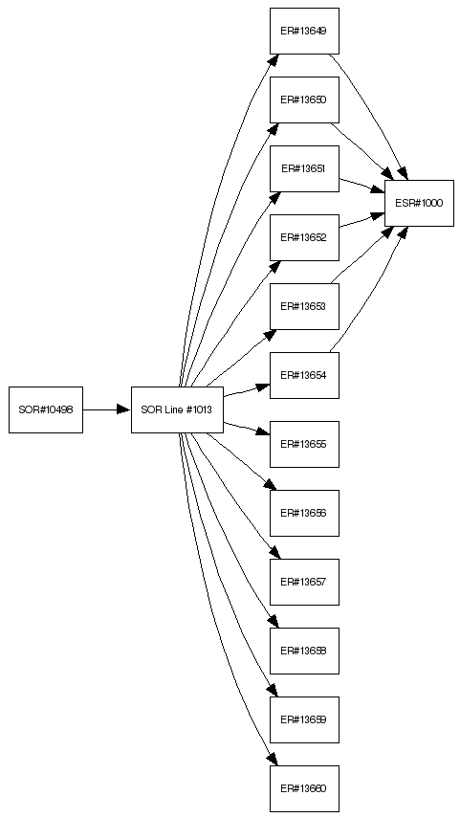
Figure 40, Sales Order Process Diagram

Sales Order Records (SOR)
The SOR Section provides access to all Sales Order Record data. The homepage displays a matrix of SOR count by business unit and SOR status. There is also a list of the last 10 SORs submitted into the system.
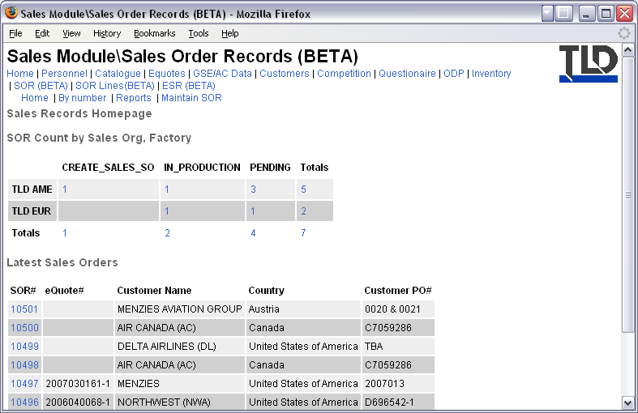
Figure 41, SOR Homepage
The SOR section contains several pages:
- “By number” allows you to directly access an SOR using its ID#.
- Reports provides a list of available reports and charts of SOR data.
- Maintain SOR is for Sales Personnel only.

SOR By Number
- If you know the reference number of an SOR, you can access it directly using this form.
- Enter the number in the empty field then hit the Submit button.
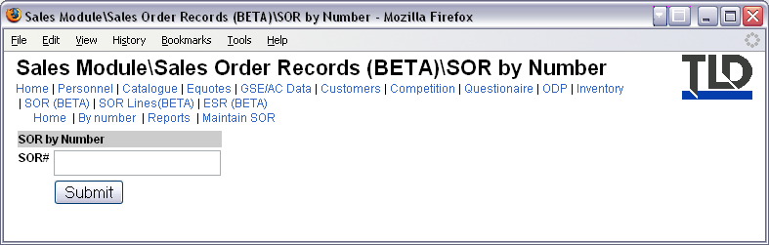
Figure 42, SOR by Number form

SOR Reports
- The Reports Page lists any available related reports that can be generated.
- There are currently no reports available yet.
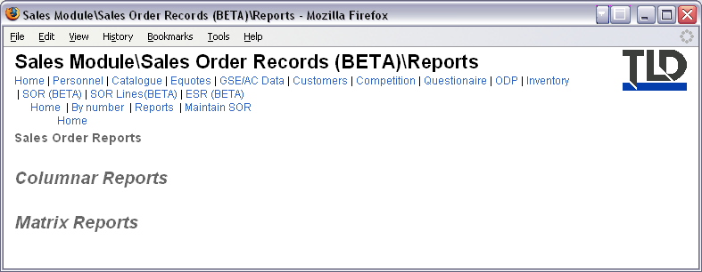
Figure 43, Reports Homepage

Maintain SOR
- The Maintain SOR page is used to add, edit and delete SOR entries.
- The Maintain SOR Section utilizes a standard Table View report. For usage instructions please refer to the Standard Forms and Reports section of this guide.
- The fields required are shown in Figure 45, Add SOR form.
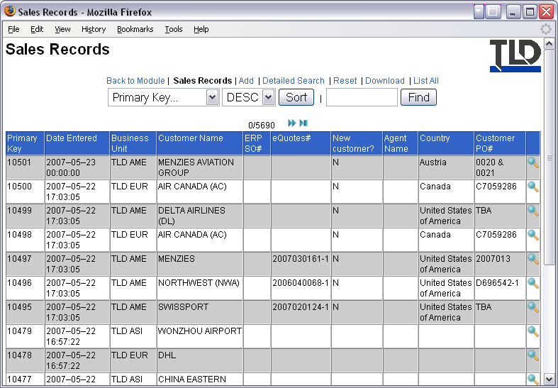
Figure 44, Maintain SORs
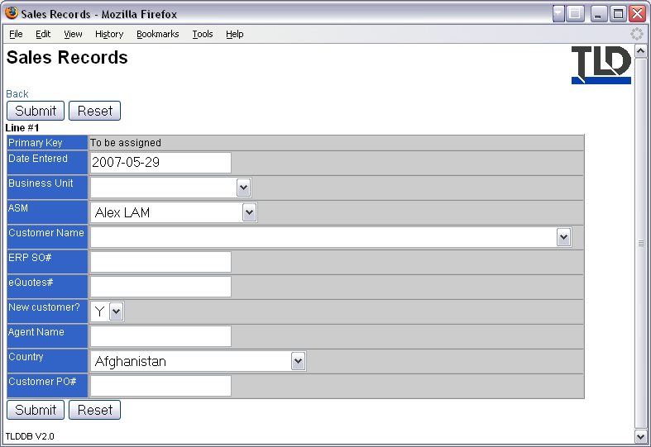
Figure 45, Add SOR form

Example SOR
- SORs are split into several sections:
- General: General information related to the SOR, also lists all SOR lines associated with the SOR.
- Files: Lists all files that are linked to the SOR.
- Change Status: Allows you to modify the status of the SOR.
- Map: Provides a diagram to illustrate the current structure and state of the whole sales order process.
- Add Line: Used to add new SOR Lines to the current SOR.
- Edit SOR: Used to modify the SOR.
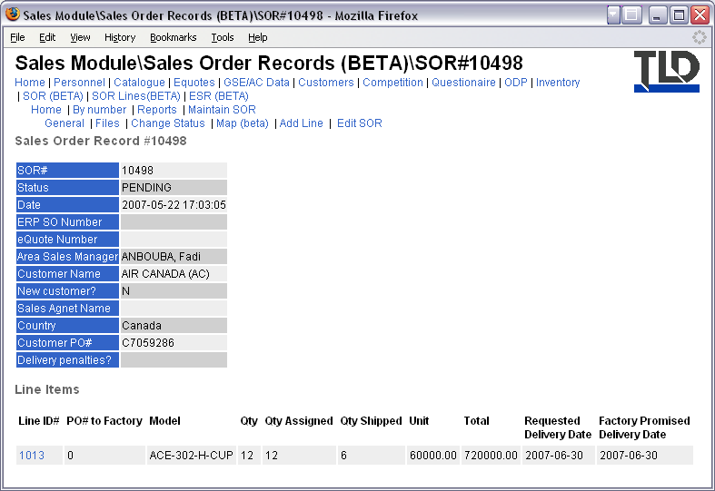
Figure 46, Example SOR

Sales Order Record Lines (SOR Lines)
The SOR Lines Section provides access to all Sales Order Record Line data. The homepage displays a matrix of SOR Line count by Factory and SOR Line status. There is also a list of the last 10 SOR Lines submitted into the system.
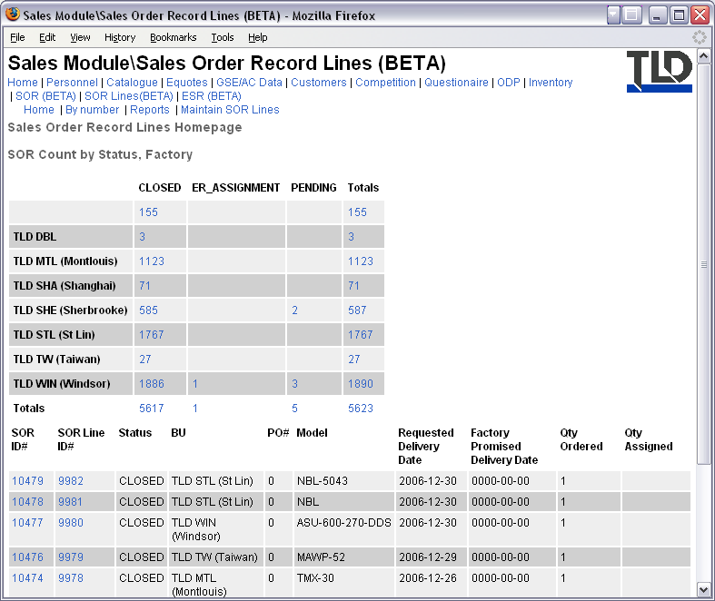
Figure 47, SOR Lines Homepage
The SOR Lines section contains several pages:
- “By number” allows you to directly access an SOR Line using its ID#.
- Reports provides a list of available reports and charts of SOR Line data.
- Maintain SOR Lines is for Sales Personnel only.

SOR Line By Number
- If you know the reference number of an SOR Line, you can access it directly using this form.
- Enter the number in the empty field then hit the Submit button.
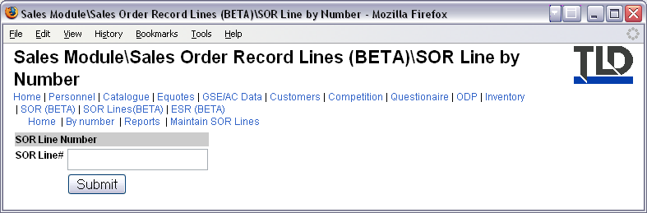
Figure 48, SOR Line by Number Form

SOR Lines Reports
- The Reports Page lists any available related reports that can be generated.
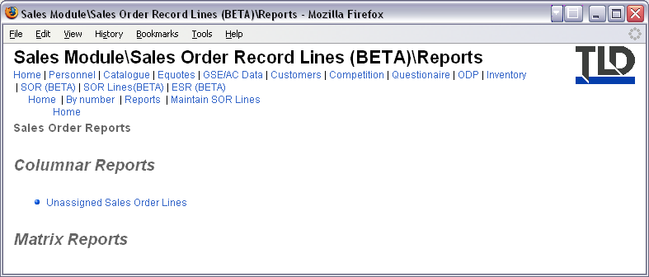
Figure 49, Reports Homepage

Maintain SOR Lines
- The Maintain SOR Lines page is used to add, edit and delete SOR entries.
- NOTE: You should not normally need to add SOR Lines here since they are created using the Add SOR Line function in an SOR. Please refer to SOR section.
- The Maintain SOR Lines Section utilizes a standard Table View report. For usage instructions please refer to the Standard Forms and Reports section of this guide.
- The fields required are shown in Figure 50, Maintain SOR Lines.
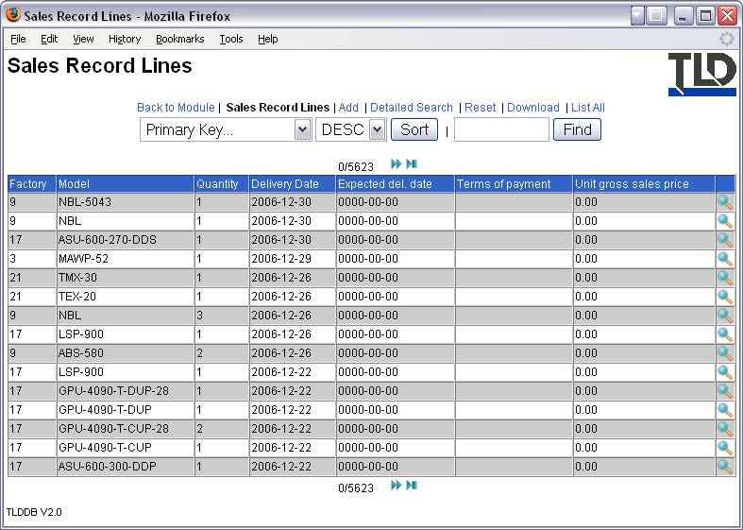
Figure 50, Maintain SOR Lines
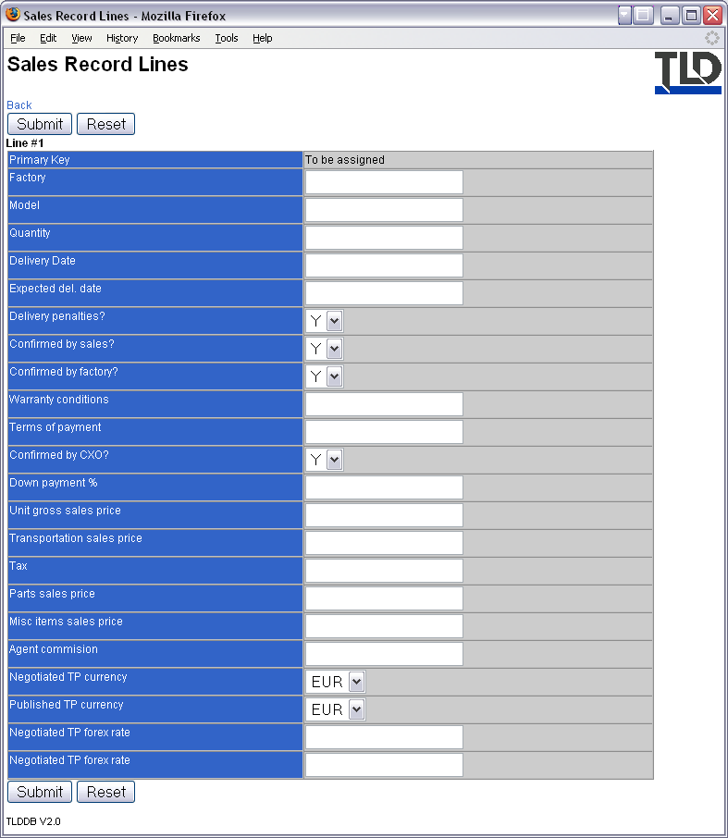
Figure 51, Add New SOR Line Form

Example SOR Line
- SOR Lines are split into several sections:
- General: General information related to the SOR line.
- Warranty: Information regarding warranty.
- Acceptance List: Indicates status of approvals required for SOR line.
- Factory: Information regarding the transaction between Sales organization and Factory.
- Customer: Information regarding the transaction between Sales organization and Customer.
- Delivery and Payment: Information regarding delivery and payment terms.
- ER: List of equipment records assigned to the SOR Line.
- Ship: Form for selecting equipment and starting the ESR process.
- Change Status: Allows you to modify the status of the SOR Line.
- SOR#xxx: Provides a convenient link to the related SOR document.
- SOR#xxx Map: Provides a convenient link to the related SOR document map.
- Map: Provides a diagram to illustrate the current structure and state of the whole sales order process.
- Edit Line: Used to modify the SOR Line.
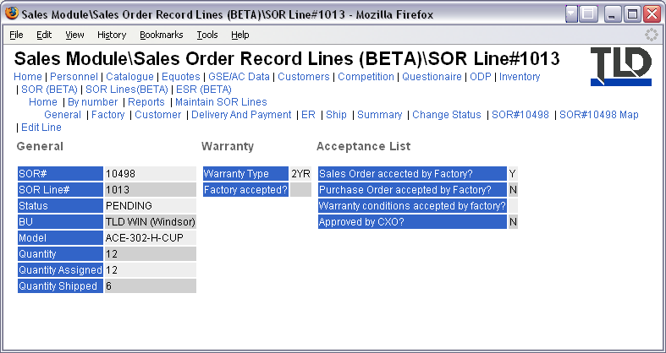
Figure 52, Example SOR Line

Equipment Shipping Records (ESR)
The ESR Section provides access to all Equipment Shipping Record data. The homepage displays a matrix of ESR count by business unit and ESR status. There is also a list of the last 10 ESRs submitted into the system.
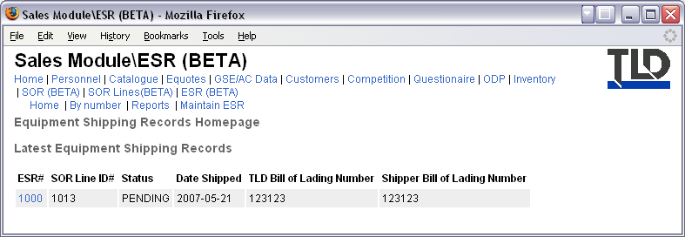
Figure 53, ESR Homepage
The ESR section contains several pages:
- “By number” allows you to directly access an ESR using its ID#.
- Reports provides a list of available reports and charts of ESR data.
- Maintain ESR is for Sales Personnel only.

ESR By Number
- If you know the reference number of an ESR, you can access it directly using this form.
- Enter the number in the empty field then hit the Submit button.
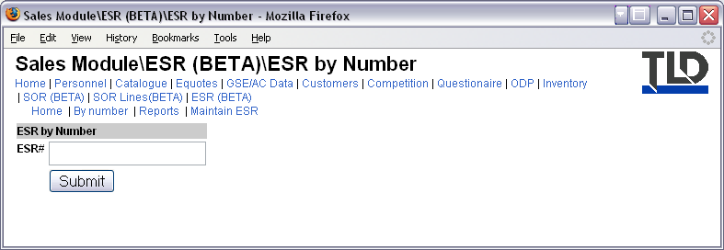
Figure 54, ESR by Number Form

ESR Reports
- The Reports Page lists any available related reports that can be generated.
- There are currently no reports available yet.
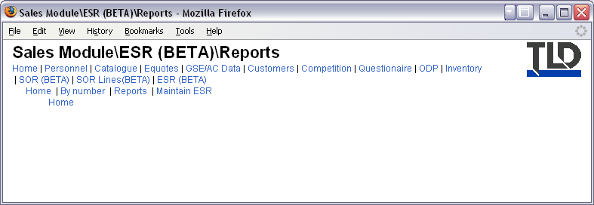
Figure 55, ESR Reports Page

Maintain ESR
- The Maintain ESR page is used to add, edit and delete ESR entries.
- NOTE: You should not normally need to add ESRs here since they are usually created from an SOR line automatically when you select equipment for shipping.
- The Maintain ESR Section utilizes a standard Table View report. For usage instructions please refer to the Standard Forms and Reports section of this guide.
- The fields required are shown in Figure 57, Add new ESR form.
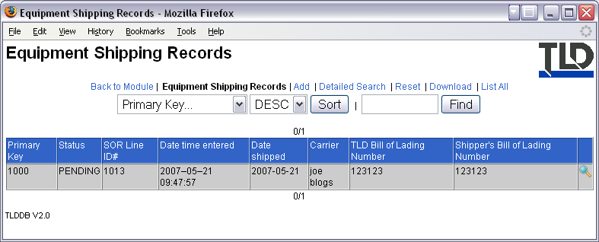
Figure 56, Maintain ESR page
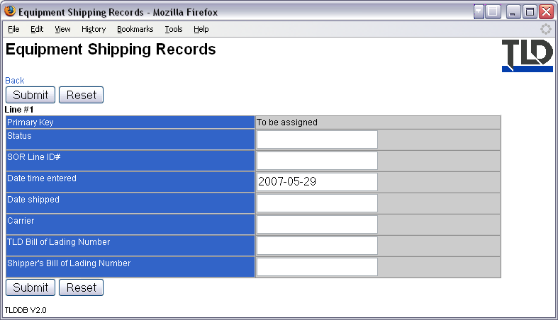
Figure 57, Add new ESR form

Example ESR
- ESRs are split into several sections:
- General: General information related to the ESR, also lists all Equipment Records associated with the ESR.
- Files: Lists all files that are linked to the ESR.
- Change Status: Allows you to modify the status of the ESR.
- Edit ESR: Used to modify the ESR.
- SOR Line#xxx: Provides a convenient link to the related SOR Line document.
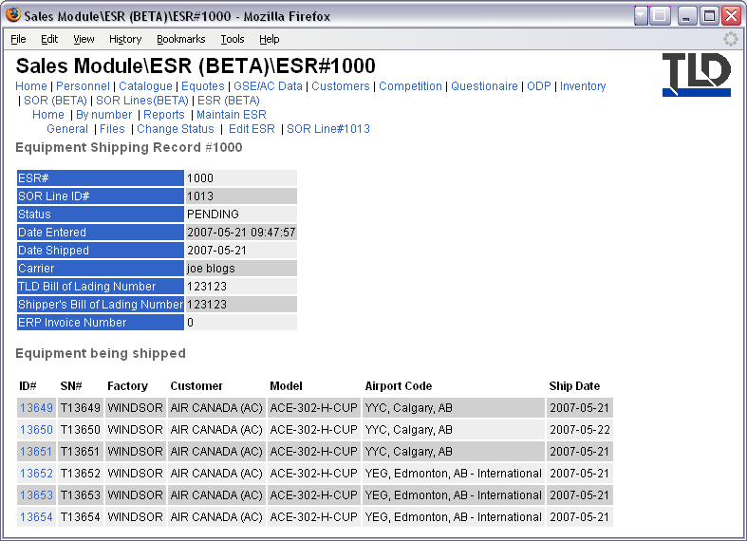
Figure 58, Example ESR

Parts Sales Module
- The Parts Sales Module is primarily for Parts Sales Personnel.
- Due to pricing information that is available in this module, only users with correct permissions are allowed access to certain areas.
- If your website account is linked to an ERP system, the ERP system code will appear in the title at the top of the page e.g. ERP 200. For information regarding the different ERP codes used, please refer to the Standard Forms, Reports and Nomenclature section of this User’s Guide.
- The module menu provides links to a number of sections. Depending on your access permissions, the menu you see may or may not appear the same as in the example below.
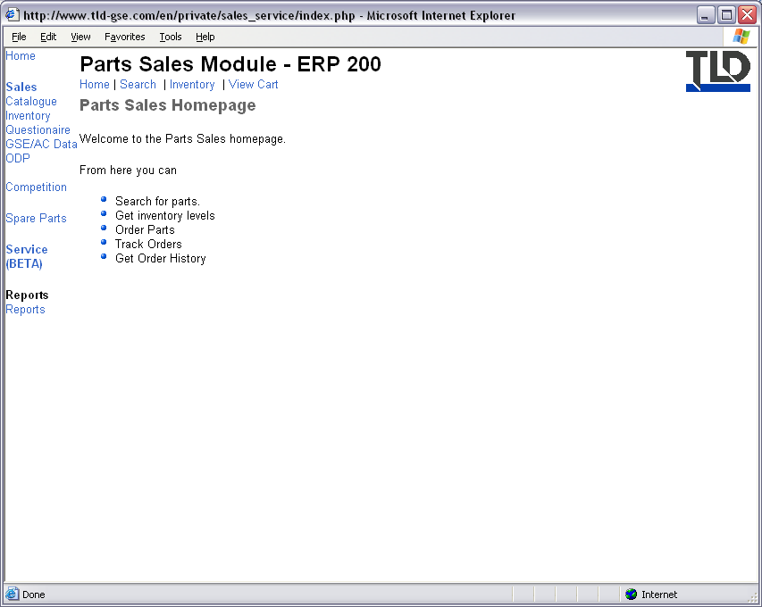
Figure 59, Parts Sales Homepage

Research Page
- The Search Page provides options for Browsing or Searching for parts information.
- HINT: Selecting particular options will take you to other modules within the Intranet because the information is owned and maintained by other departments.
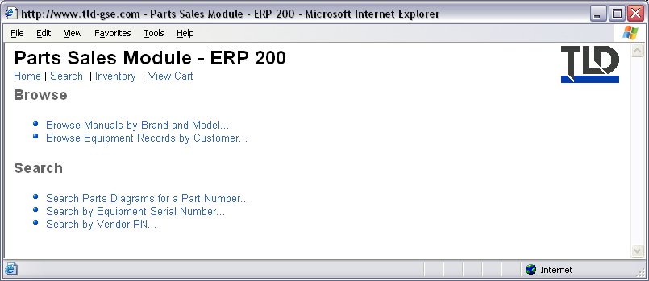
Figure 60, Parts Sales Research Page

Inventory Page
- From the Inventory Page you can quickly see part information and on one page.
- HINT: The information contained in this first page is cached information taken from the ERP systems every twenty four hours.
- To get the latest information regarding a part hit the Check link in the “Online Avail.” column.
- To add an item to your shopping cart, hit the Buy link.
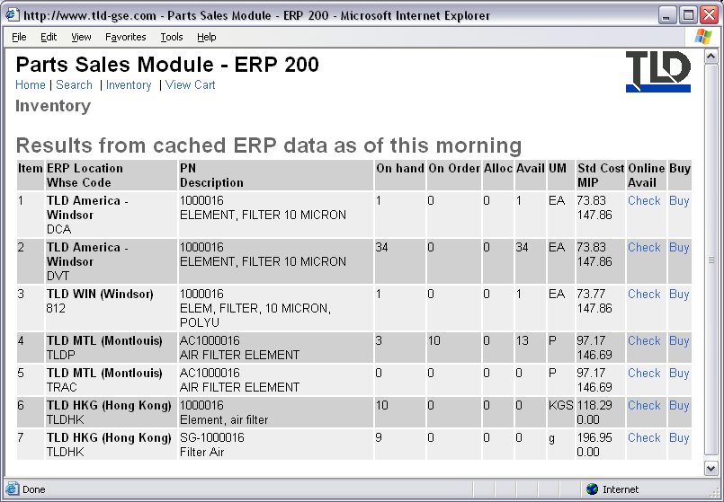
Figure 61, Parts Sales Inventory Page

Cart Section
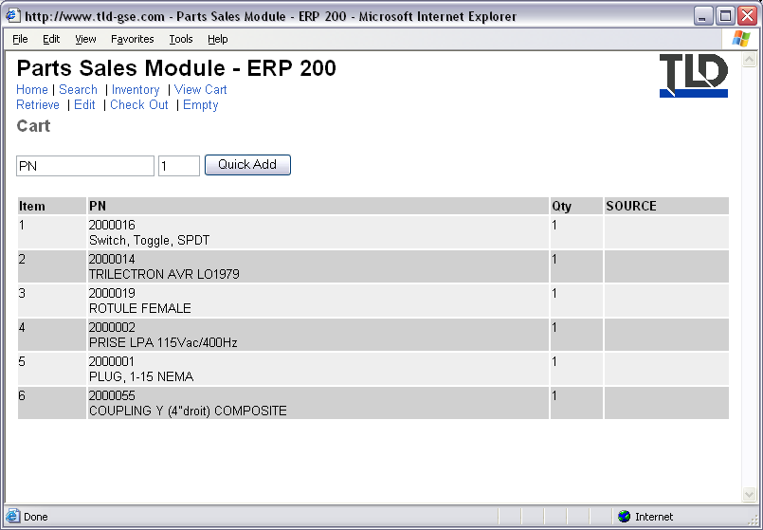
Figure 62, Example Cart

Service Module
- The Service module contains data and information owned or maintained by Service personnel.
- From the homepage you can go directly to an Equipment Record, if you know the serial number, using the form at the top of the page.
- If you do not know the equipment serial number you can browse all equipment. This utilizes a standard Table View report. For usage instructions please refer to the Standard Forms and Reports section of this guide.
- At the bottom of the homepage are links to other service related information that is owned or maintained by Product Support and is therefore located in the Product Support Module. Please refer to the Product Support Module section of this user’s guide for information available in the Product Support Module.
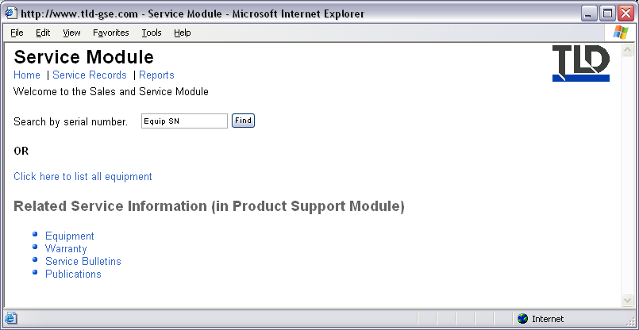
Figure 63, Service Module Homepage

Service Records Section
- The Service Records section of the Service Module allows you to search and maintain Service Records.
- At the homepage, you can display an existing Service Record, if you know the SR#, by using the form shown.
- If you have the correct permissions, you can maintain SRs by using the Maintain SRs link. The Maintain SRs page utilizes a standard Table View report. For usage instructions please refer to the Standard Forms and Reports section of this guide.
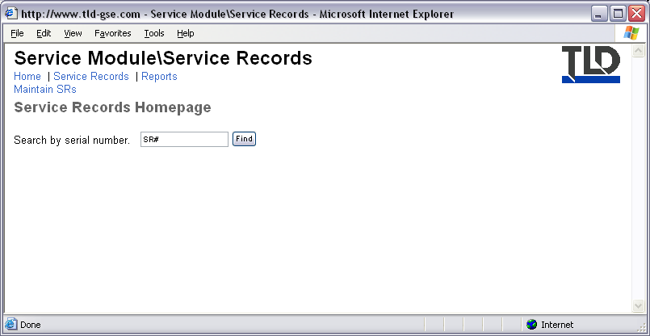
Figure 64, Service Records Homepage

Service Records Reports Section
- The Reports Page lists any available related reports that can be generated.
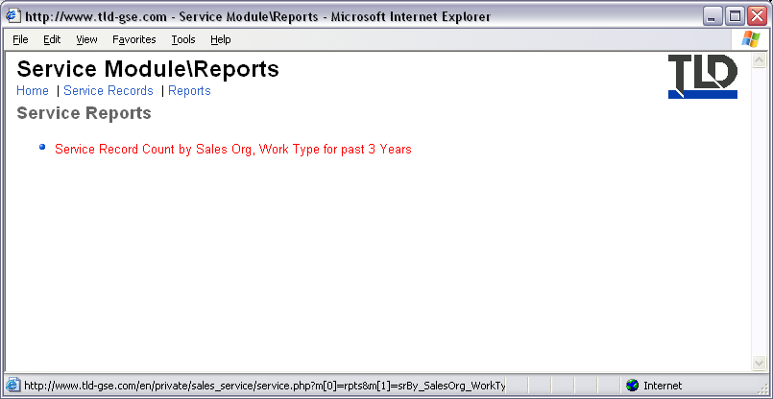
Figure 65, Reports Page

Product Support Module
The Product Support Module contains seven sections.
- PDC (Product Demerit Claims)
- Equipment (Equipment Records)
- WC (Warranty Claims)
- SB (Service Bulletins)
- Publications (Manuals, Parts Diagrams)
- ODP (Order Delivery Planning)
- Admin (For Product Support Personnel only)
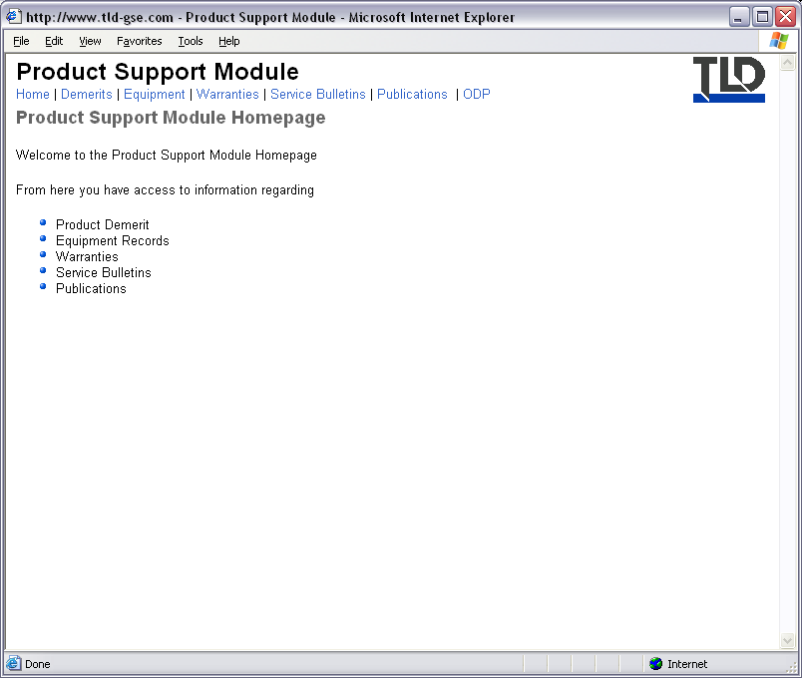
Figure 66, Product Support Homepage

PDC Section
The PDC Section provides access to all Product Demerit Claim data. The homepage displays a matrix of PDC count by business unit and PDC status. There is also a list of the last 10 PDCs submitted into the system.
The PDC section contains several pages:
- Submit Demerit provides a form for creating a new PDC.
- Demerit by Number allows you to access a PDC using its ID#.
- Search allows you to search PDCs by keywords.
- Reports provides a list of available reports and charts of PDC data.
- Help displays an introduction and instruction for using the PDC system.
- Maintain Demerits is for Product Support Personnel only.
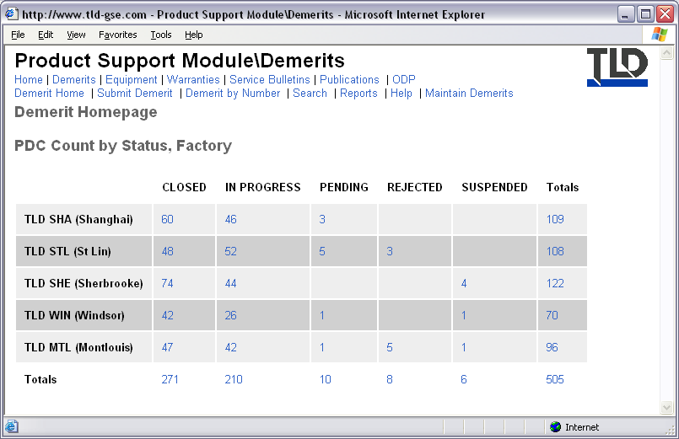
Figure 67, PDC Homepage

Equipment Section
- From the homepage you can go directly to an Equipment Record using the form at the top of the page, if you know the serial number.
- If you do not know the equipment serial number you can browse all equipment. This utilizes a standard Table View report. For usage instructions please refer to the Standard Forms and Reports section of this guide.
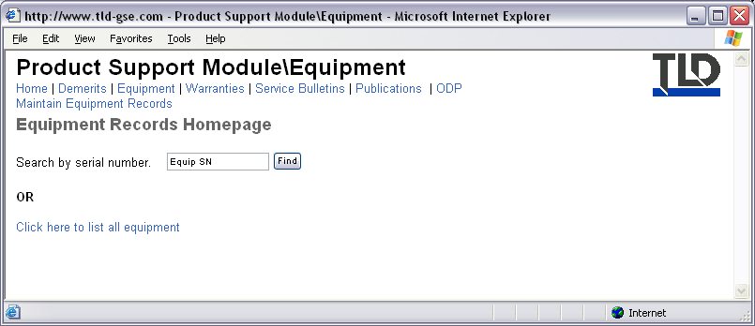
Figure 68, Equipment Section
- Once you have selected the correct unit, you will be presented with its Equipment Record. An example of an equipment record is given below.
- HINT: If a unit is out of warranty, according to its Equipment Record, a warning will appear at the top of the page.
- An Equipment Record is split into multiple tabs with links to each tab in a menu.
  - General: This section provides basic information regarding the unit including the serial number and description of options that were installed on the unit itself.
  - Customer Details: Includes information regarding the last known owner and location of the equipment.
  - Warranty: Includes warranty length and any special warranty conditions.
  - Serial Numbers: Contains a list of major components, such as engine and transmission, and their respective serial number.
  - Publications: Lists any linked manuals and related service bulletins pertaining to this unit.
  - Schematics: Lists any linked schematic diagrams to this unit.
  - Edit: For editing this equipment record. HINT: Depending on your access permissions, you may or may not see this menu item.
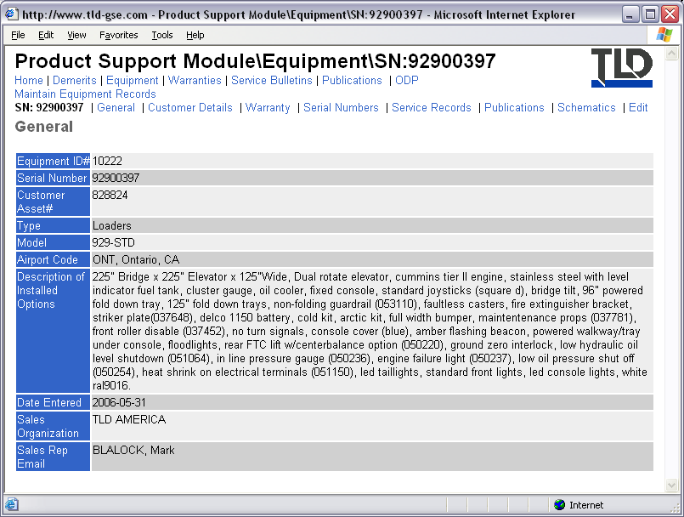
Figure 69, Example Equipment Record

Warranty Section
The Warranty Section provides access to all Warranty Claim information. The homepage provides a form for viewing a WC if you know the WC#. Enter the number into the field and hit the ‘Show WC’ button. The last 10 WCs entered in the system are also listed for reference.
There are 2 menu items:
- Reports, The Reports Page lists any available related reports that can be generated.
- Maintain Warranties (For Product Support Personnel only)
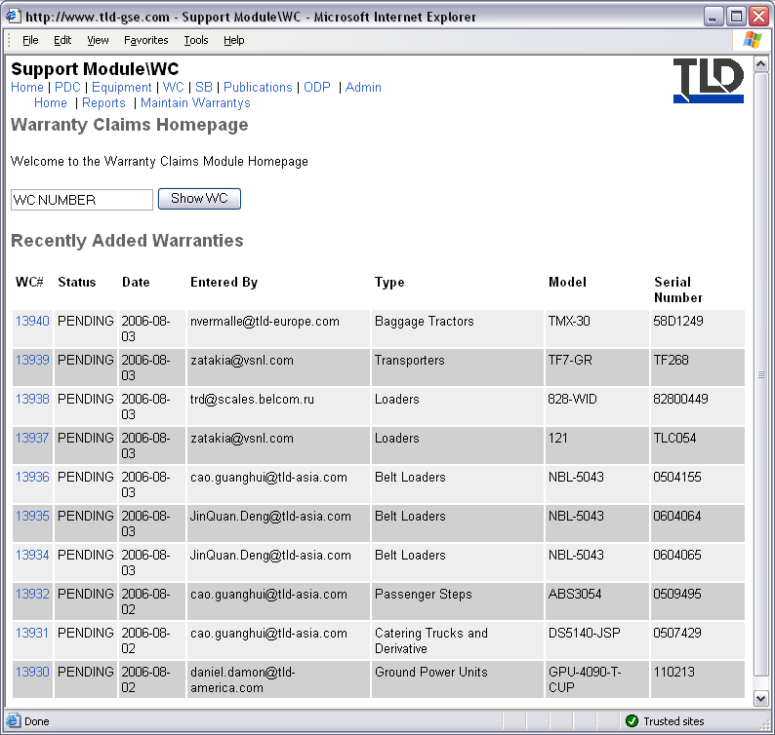
Figure 70, Warranty Claims Homepage

Warranty Claim
When viewing a WC you are presented with several tabbed pages.
- General, shows general information regarding the warranty.
- Support, contains WC information maintained by Product Support.
- Service, contains WC information maintained by Service.
- Parts, contains WC information maintained by Spare Parts Sales.
- Files, lists any files linked to the WC.
- Transfer to VWC, for use by Product Support personnel only to automatically generate a Vendor Warranty Claim.
- Edit, only used by Product Support personnel.
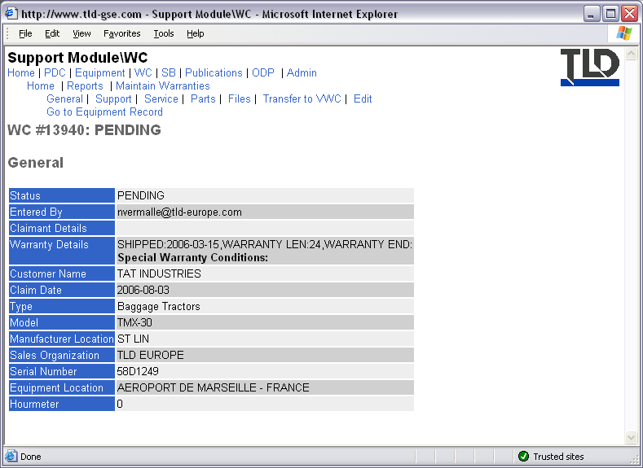
Figure 71, WC Example

Service Bulletins Section
- From the homepage you can go directly to a Service Bulletin using the form at the top of the page, if you know the SB number.
- The last 10 SB created are listed for reference.
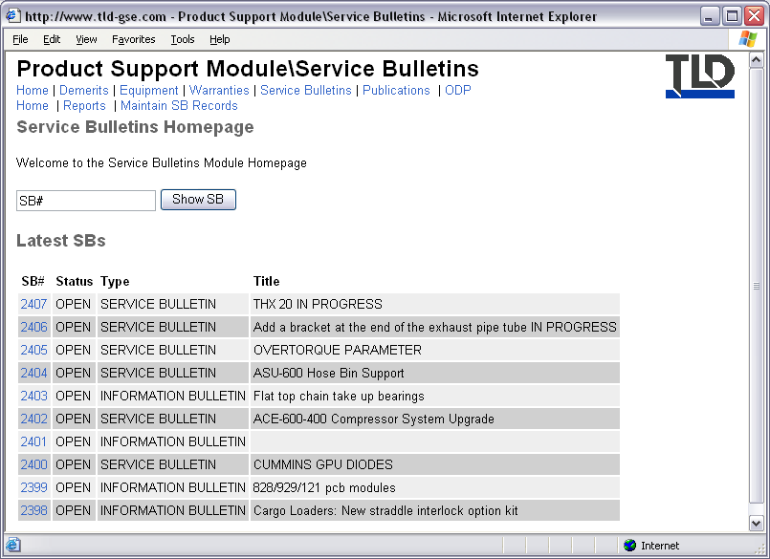
Figure 72, Service Bulletins Homepage

Example SB
- An SB is split into tabbed pages. The first page, General, provides general information regarding the SB.
- Affected Equipment, lists all equipment that is affected by the SB.
- Attachments, lists any linked files associated with the SB.
- Edit, only for Product Support personnel.
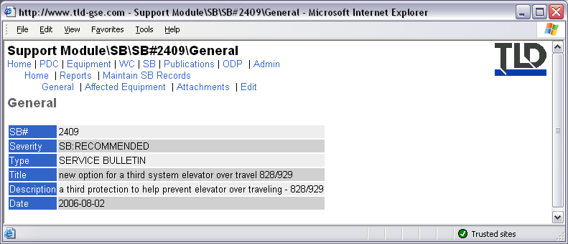
Figure 73, Example Service Bulletin
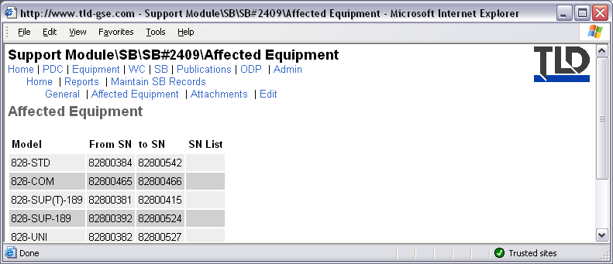
Figure 74, Affected Equipment List
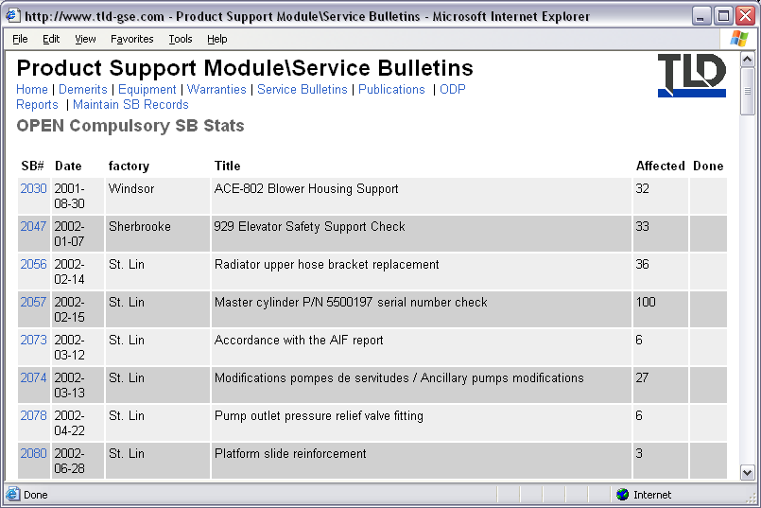
Figure 75, Example Report

Publications Module
- The Publications module consists of the following sections:
- Manuals, online manuals for TLD equipment and competitor equipment.
- Documents, parts diagrams and manual sections used to make up online manuals.

Manuals
- From the homepage you can go directly to a manual, if you know the manual ID#, by typing it in the field provided and hitting the Submit button.
- You can also browse manuals by Brand and Model using the link provided on the homepage.
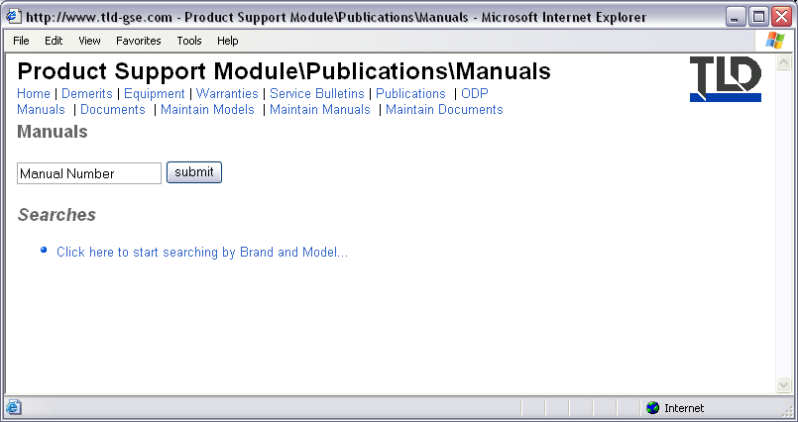
Figure 76, Manuals Section

Example Manual
- Once inside a manual you are given a list of all documents that the manual contains.
- To view an individual document, hit the View link.
- In the Manual menu:
  - RSPL (Recommended Spare Parts Lists), creates a RSPL base on the Parts Diagrams in the manual.
  - CDROM manual, creates a zipped file that can be used to create a autorun manual on cdrom.
  - Chapter 4 PDF, creates a chapter 4 parts book in either English or French.
  - Edit, only used by Product Support personnel.
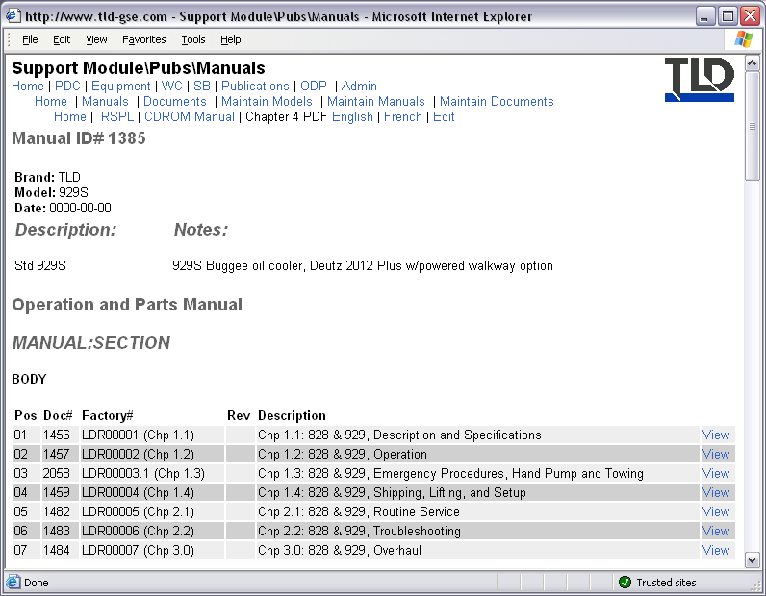
Figure 77, Example Manual

Documents Section
- From the homepage you can go directly to a document, if you its document ID#, by entering it in the field and hitting the Submit button.
- You can search for documents containing a particular part number using the “Click here to start searching by Part Number...” link.
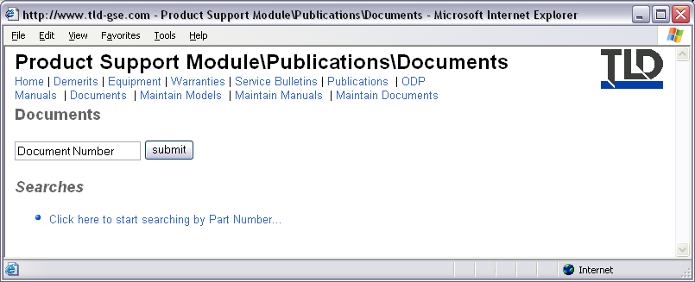
Figure 78, Documents Section

Example Document
- There are two types of documents: parts diagrams and manual sections.
- Parts diagrams consist of a picture and an associated parts list.
  - If there is a picture attached to the parts diagram then an icon will appear in the top right corner. Hit the icon to view the picture.
- Manuals sections consist of a description and an attached PDF file containing the actual manual section. To view the PDF, hit the PDF icon that appears in the top right corner.
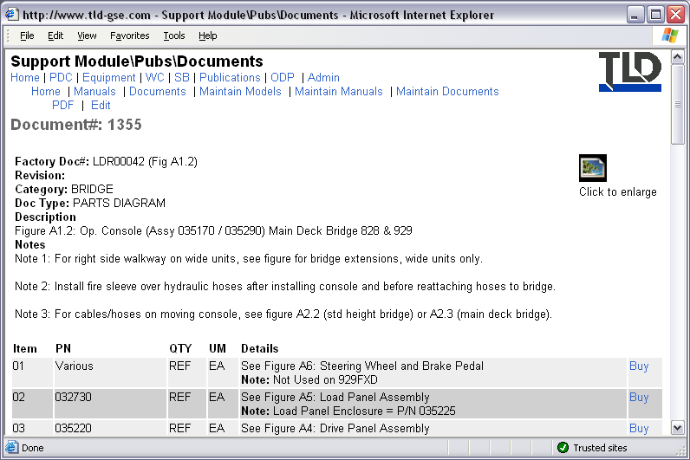
Figure 79, Example Parts Diagram
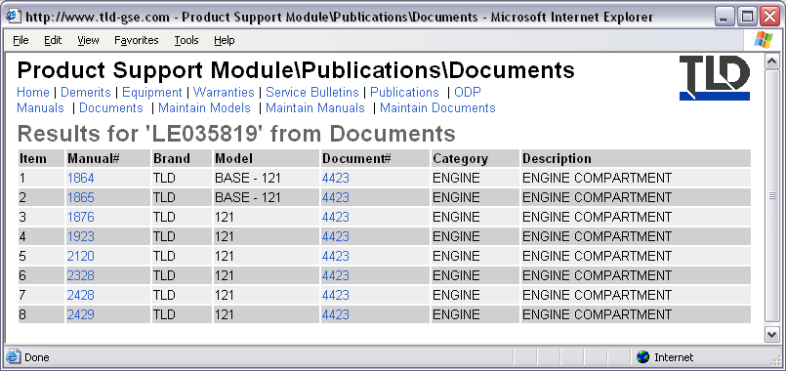
Figure 80, Example search results by Part Number

Old Service Module
The old service module will eventually replaced by the new Sales and Service module.
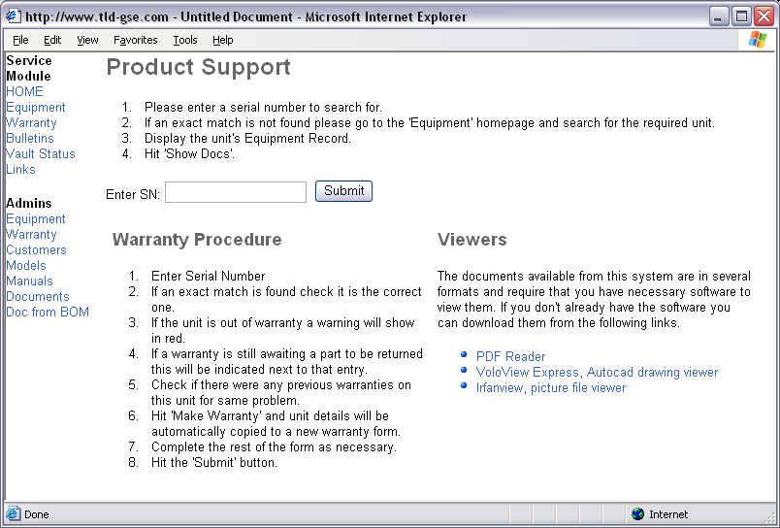
Figure 81, Old Service Module Homepage

Manufacturing Module
- The manufacturing module consists of the following sub-modules:
  - Quality
  - Engineering
  - Purchasing
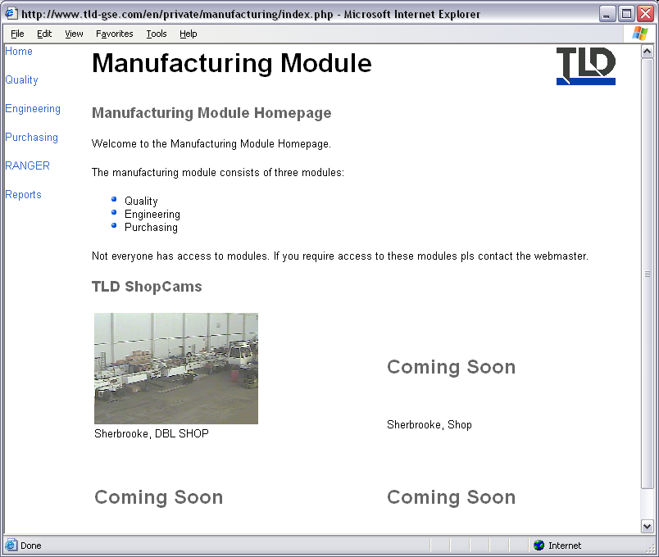
Figure 82, Manufacturing Module Homepage

QA Module
- The QA Module consists of the following sections and pages:
  - NCR (Non-Conformance Reports)
  - CPA (Corrective and Preventive Actions)
  - Intelex, links to the Intelex ISOSoft system.
  - Procedures, links to public documents in the ISOSoft system.
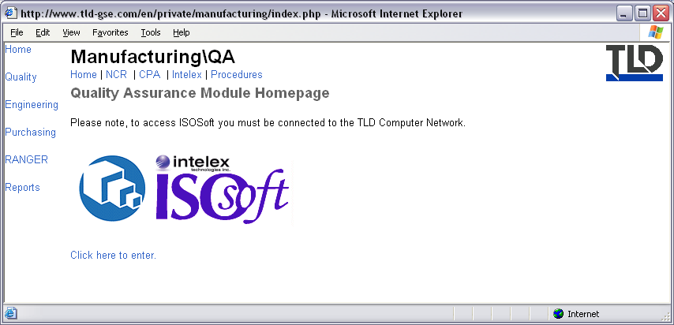
Figure 83, QA Module Homepage

NCR Section
- The NCR homepage displays a matrix with the counts of NCR by business unit and NCR Status.
- The last 10 NCRs entered into the system are also displayed on the homepage.
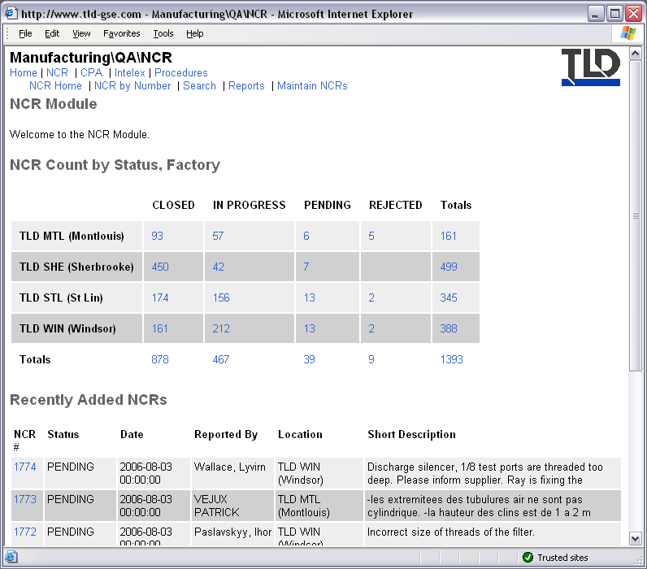
Figure 84, NCR Section Homepage

Example NCR
- An NCR is split up into several tabbed pages.
- Description, provides general information regarding the NCR.
- Action-Conclusion, displays information regarding the solution.
- Costs, displays information regarding costs associated with the NCR.
- Files, displays any files that are linked to the NCR.
- Tasks, displays any tasks that are linked to the NCR.
- Print Version, displays an NCR with formatting suitable for printing.
- Change Status, used by QA personnel to change the status of an NCR.
- Assign to Vendor, used by QA personnel to attribute an NCR to a particular vendor.
- Edit, only used by QA personnel.
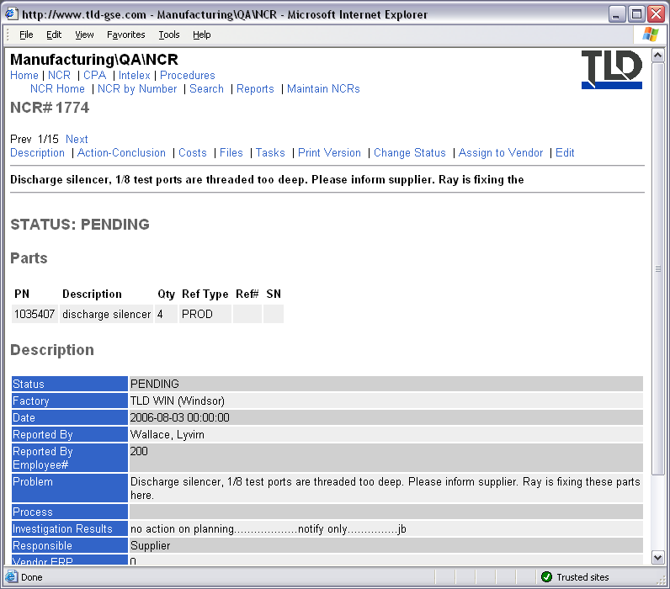
Figure 85, Example NCR Document

CPA
- The CPA homepage displays the last 10 CPAs entered into the system.
- From the menu you have access to:
- Submit CPA, provides a form for creating and submitting a new CPA into the system.
- By Number, if you know the CPA ID# you can use this page to go directly to it.
- Reports, The Reports Page lists any available related reports that can be generated.
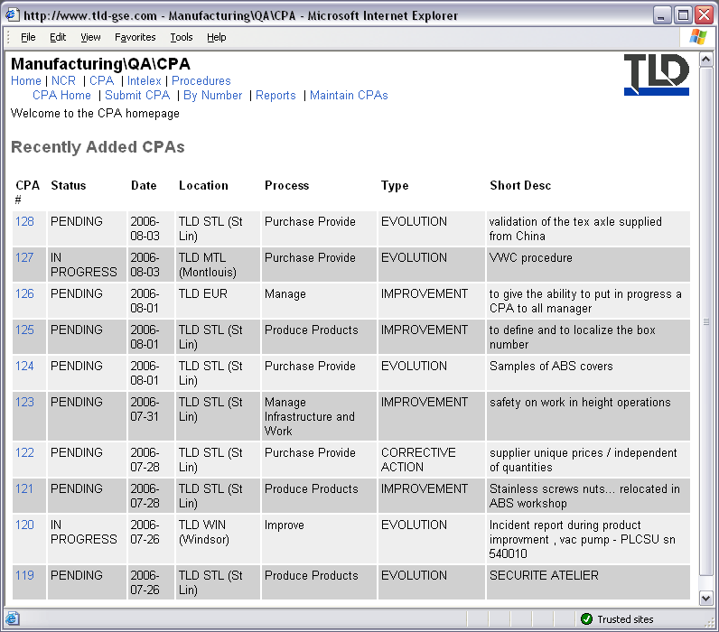
Figure 86, CPA Homepage

Example CPA
- CPAs are split into several tabbed pages:
  - General, general information regarding the CPA.
  - Tasks, lists any tasks that are linked to this CPA.
  - Files, lists any files linked to this CPA.
  - Links, lists any links to other documents, such as PDC, NCR, etc.
  - Change Status, used by QA personnel to change the NCR status.
  - Edit, only used by QA personnel.
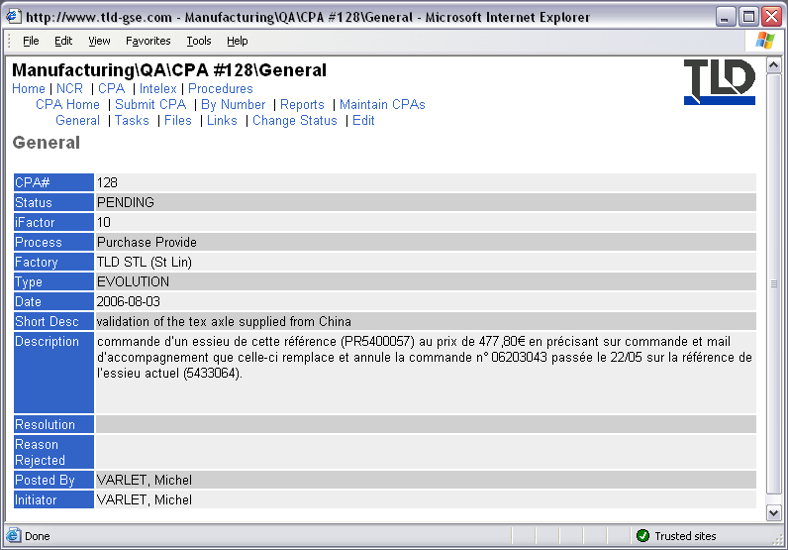
Figure 87, Example CPA Document

Engineering Module
- The Engineering Module consists of the following sections:
  - CBOM (Customised Bill of Materials)
  - BOM (Bill of Materials)
  - EDM (Electronic Data Management)
  - Availability
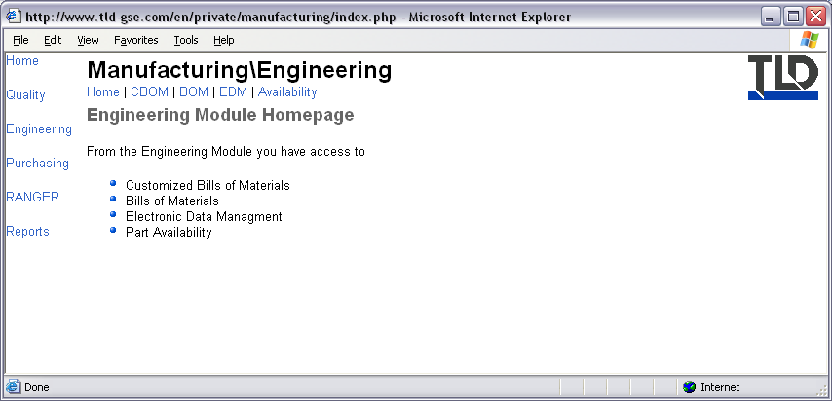
Figure 88, Engineering Homepage

CBOM
- From the CBOM homepage you can view a CBOM from any BAAN company.
- Select the business unit, enter the serial number and hit the Show BOM button.
- To show a CBOM as of a particular date, change the date field which defaults to the current date.
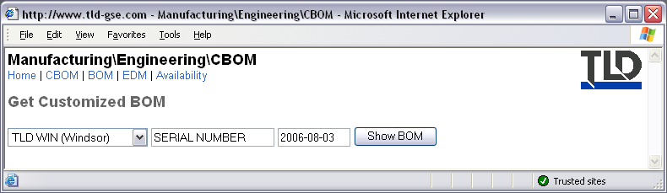
Figure 89, CBOM Homepage
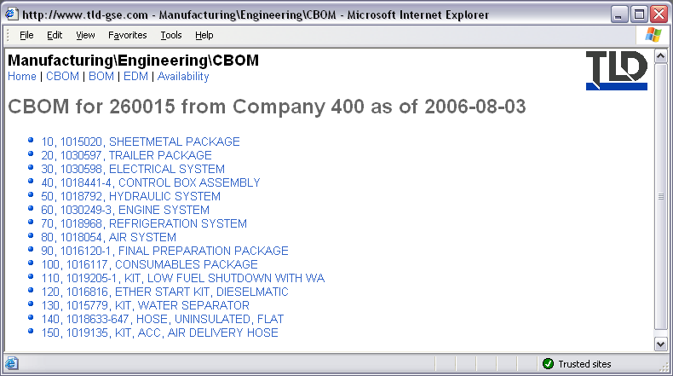
Figure 90, Example CBOM

BOM
- From the BOM homepage you can view a BOM from any TLD business unit.
- Select the business unit, enter the part number and hit the Show BOM button.
- To show a BOM as of a particular date, change the date field, which defaults to the current date.
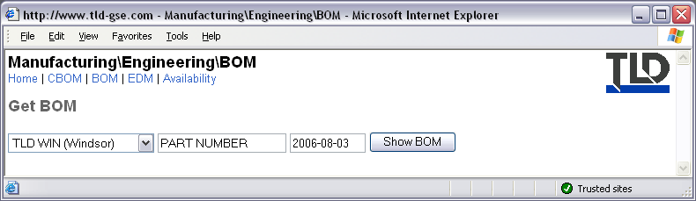
Figure 91, BOM Homepage
- The diagram below shows an example BOM.
- The default is to show a single level.
- If a BOM has multiple levels you can see the entire BOM by hitting the MULTI Level link.
- To revert back to single level, hit the SINGLE Level link.
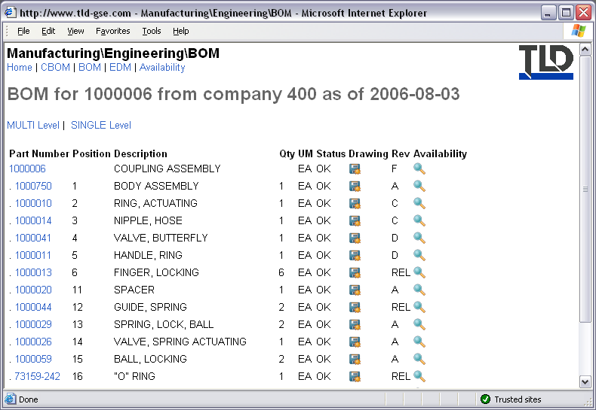
Figure 92, Example BOM
EDM
You can view EDM data for a part from the EDM homepage. Select the business unit, enter the part number into the field and hit the Show EDM button.
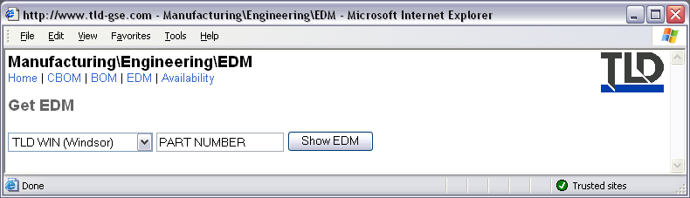
Figure 93, EDM Homepage
EDM data will show all available drawings for a part number throughout the life of a part. Any drawings that are available will show up as a link in the PDF column. Hitting the Photo link will search in the database for an associated picture.
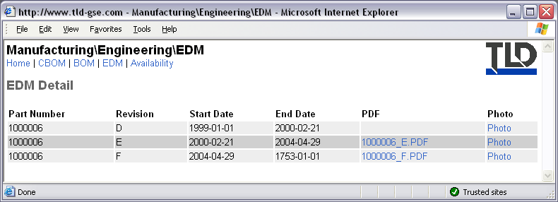
Figure 94, Example EDM

Purchasing Module
- The Purchasing Module consists of the following sections:
  - Vendors
  - Xref
  - PO
  - VWC
  - RFQ
  - Std Cost
  - Reports
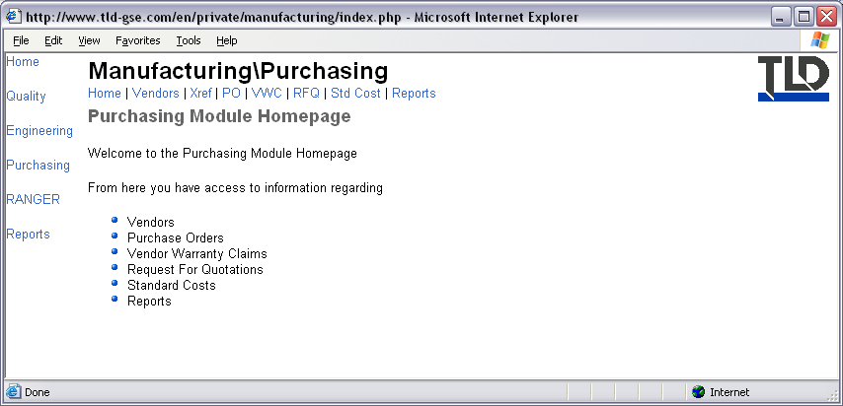
Figure 95, Purchasing Module Homepage

Vendors Section
- The Vendors Section provides access to information regarding vendors that have access to the TLD Vendors Site.
- To browse for a vendor, select the TLD BU.
- A vendor list of all vendors linked to the selected BU will appear.
- HINT: To quickly search the page for a vendor hit CTL+F on your keyboard to use your web browsers search function.
- Once you’ve found the line, for the correct vendor, hit the Details to see the Vendor Details page.
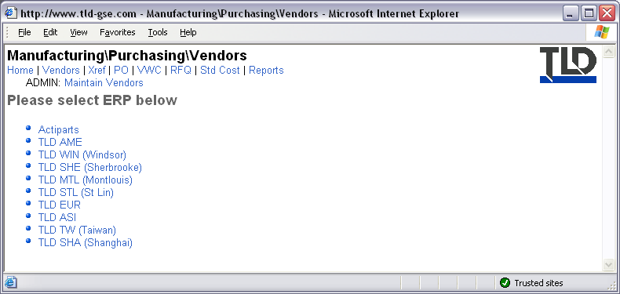
Figure 96, Vendors Section
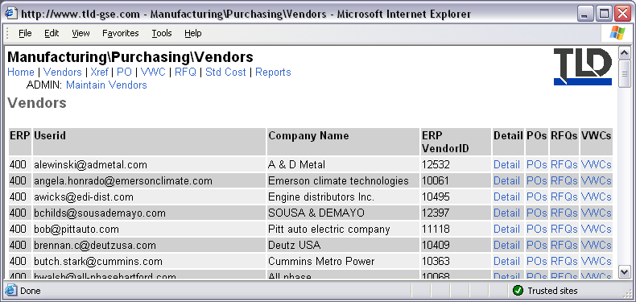
Figure 97, Vendors List
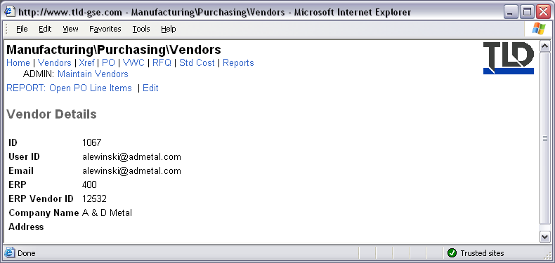
Figure 98, Vendor Details Page

Vendor Cross Reference Section
- The Vendor Cross Reference Section is a very powerful tool that allows you to do research in the TLD vendor part number system.
- To search by Vendor PN hit the ‘Search by Vendor PN’ link on the homepage.
- In the form that appears, select the BU you want to search in then enter a vendor part number to search for. Hit the Submit button.
- The system will search for the vendor’s part number for matches.
- If there are any matches it then uses the corresponding TLD part number to search the system again to find other vendors of the same part.
- In the example below there are three vendors for the part 1000016 that was originally searched for.
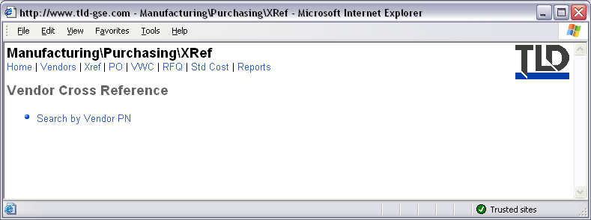
Figure 99, Vendor Cross Reference Homepage
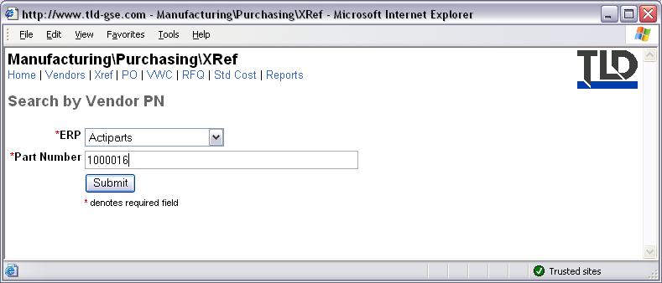
Figure 100, Vendor Part Number Search Page
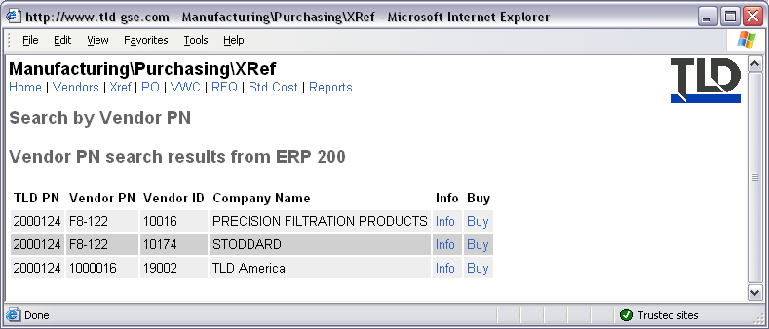
Figure 101, Example Vendor Part Number Search Results

Purchase Orders Section
- The Purchase Orders Section allows you to view purchase orders from any available TLD ERP system.
- At the PO Homepage, first select the BU to search in.
- Enter the PO# to search for then hit the Submit button.
- If a corresponding PO is found it will appear on the next page.
- Two fields to pay special attention to are the Change and FAI (First Article Inspection) fields.
- The Change field indicates whether there has been a BOM or drawing change for the line item.
- The FAI field indicates whether the line item must undergo a FAI upon receipt.
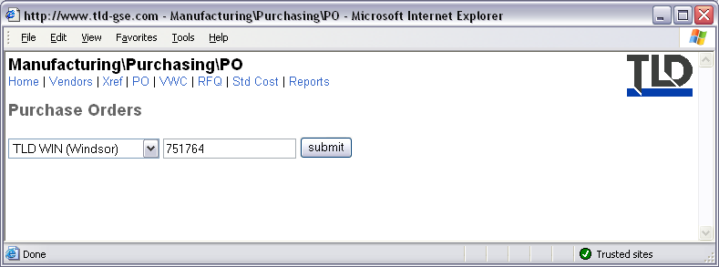
Figure 102, Purchase Orders Homepage
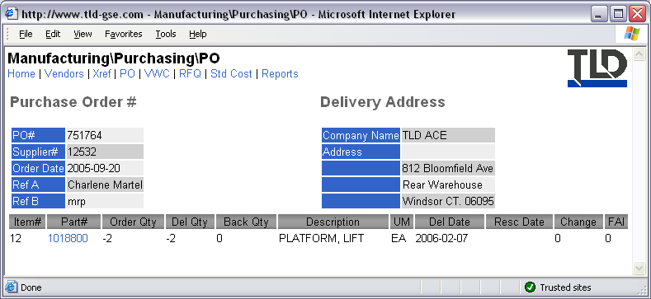
Figure 103, Purchase Order View Page

Vendor Warranty Claims Section
- The Vendor Warranty Claims Section provides access to VWC entered into the system.
- The VWC Homepage lists the last 10 VWC entered into the system.
- If you know the number of a VWC, you can view by using the By Number link.
- To determine whether there are VWC claims associated with a WC, use the By WC# link.
- The Maintain VWC menu item is for Purchasing Personnel only.
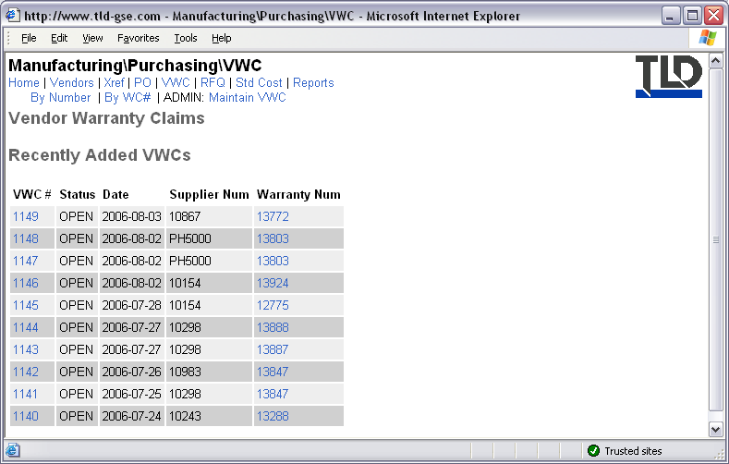
Figure 104, Vendor Warranty Claims Homepage
- The figure below shows an example VWC.
- A VWC is split into several tabbed pages.
- Part List, displays list of parts being claimed.
- Notes, messages to and from the vendor regarding this VWC.
- Print Version, displays the VWC in a printer friendly format.
- Edit, for Purchasing personnel only.
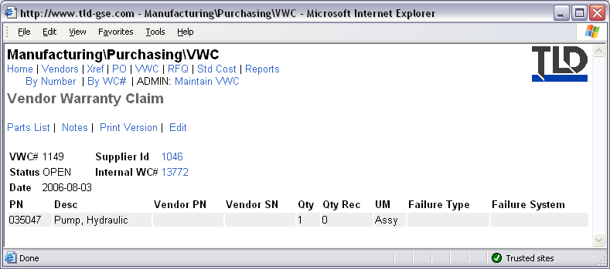
Figure 105, VWC Example

Request For Quotations Section
- The Request For Quotations Section allows you to view RFQs from any BAAN company.
- At the RFQ Homepage, first select the BU to search in.
- Enter the RFQ# to search for then hit the Submit button.
- If a corresponding RFQ is found it will appear on the next page.
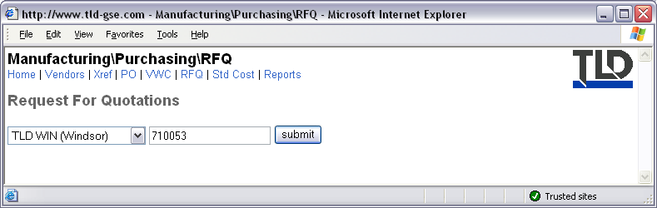
Figure 106, Request for Quotation Homepage
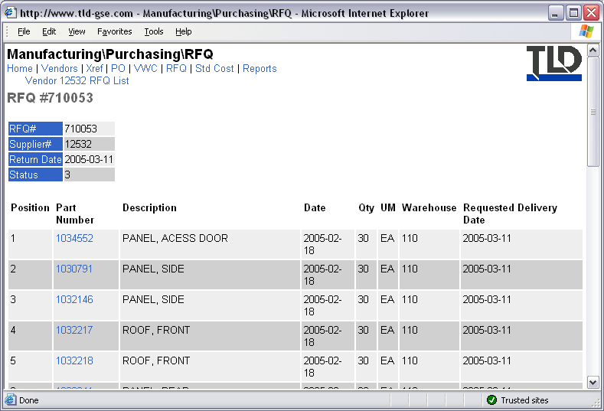
Figure 107, RFQ Example

Ranger Project Page
- Files used by the Ranger project are stored in a shared folder on a server in Windsor. It is not located on the Intranet.
- A link to the Range shared network folder is provided on the Ranger Project page.
- You must have network permission to the Ranger folder in order to access. You typically must be a member of the global group ‘gg_RANGER’. Contact your local MIS Manager for more information.
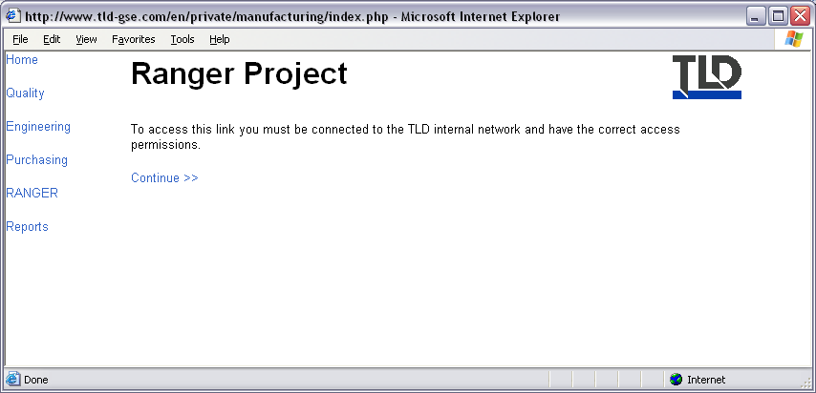
Figure 108, Range Project Page
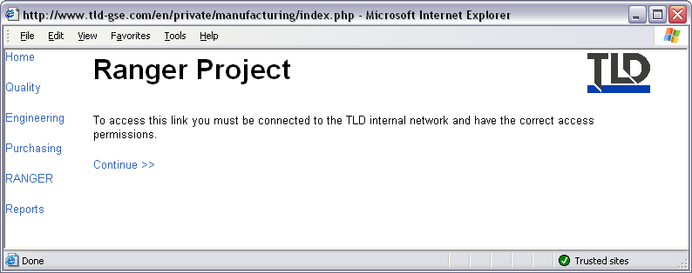
Figure 109, Ranger Homepage

Manufacturing Reports
- The Manufacturing Reports homepage lists two available reports: KPI and GS.
- The KPI report is located on our Intranet.
- The GS report is located on a network file server in Windsor.
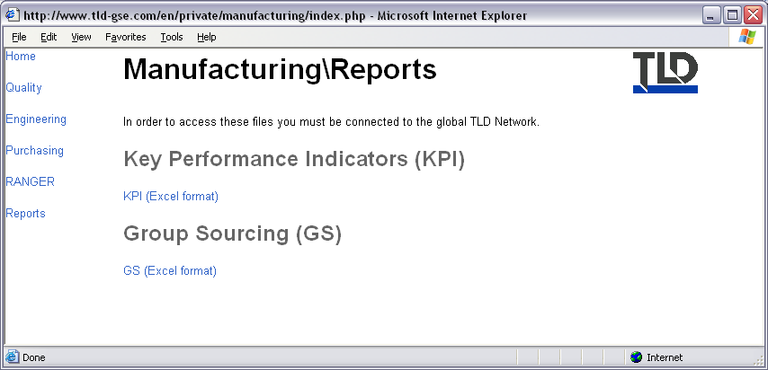
Figure 110, Manufacturing Reports Page

MIS Module
- The MIS Module consists of two sections: TTS (Trouble Ticketing System) and Inventory.
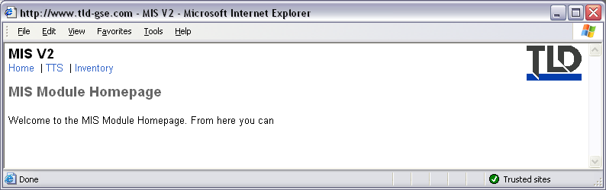
Figure 111, MIS Module Homepage

Trouble Ticket System (TTS)
- TTS allows you to complete and submit MIS forms online.
- To file a trouble ticket, hit Forms.
- Click the Open New Trouble Ticket link.
- Complete the form that appears then hit the Submit button.
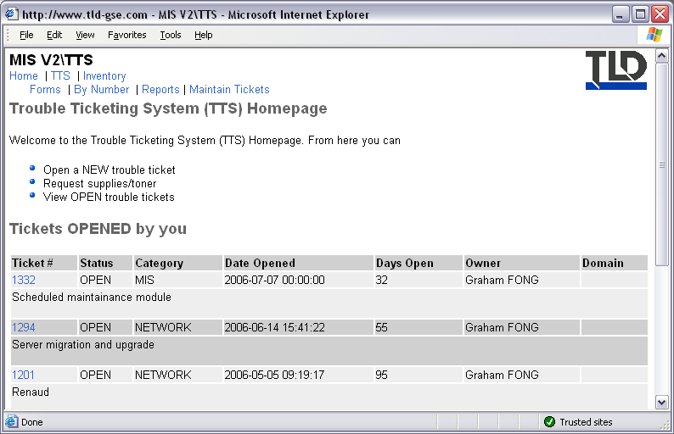
Figure 112, TTS Homepage
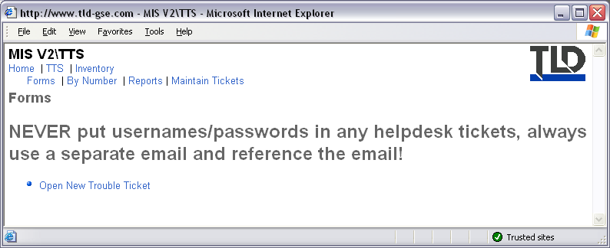
Figure 113, TTS Forms
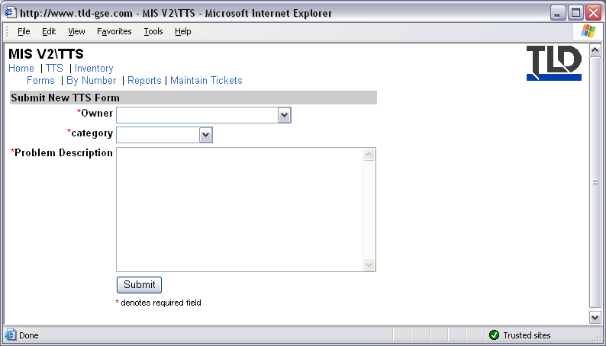
Figure 114, Submit New TTS Form

Inventory
The Inventory section is used by MIS Personnel only.
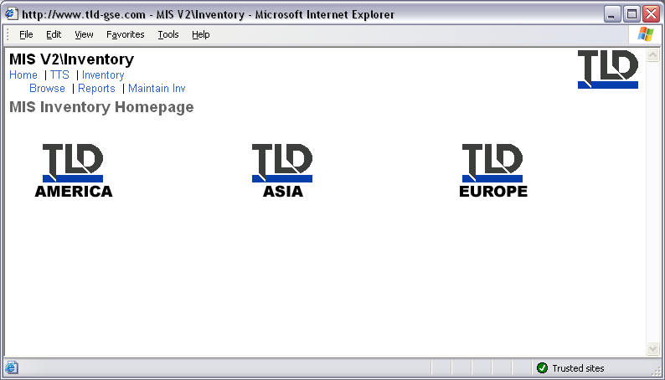
Figure 115, Inventory Homepage

Table of Figures
Figure 1, Example Table View 5
Figure 2, Example Columnar Report 5
Figure 3, Example Multi Level Report 6
Figure 4, TLD Intranet Homepage 8
Figure 5, My Account Homepage 9
Figure 6, Account Edit Form 10
Figure 7, Change Password Form 10
Figure 8, Change Photo Form 11
Figure 9, Groups Page 12
Figure 10, Tasks Lists Homepage 13
Figure 11, Example of a Task 14
Figure 12, Add Comment Form 14
Figure 13, Transfer Task Form 15
Figure 14, Reschedule Task Form 15
Figure 15, Mark as Completed confirmation page 16
Figure 16, Events Homepage 17
Figure 17, TLD Directory Homepage 18
Figure 18, Example Directory Listing 18
Figure 19, Example vCard 19
Figure 20, Departments Section 19
Figure 21, Organization Chart Page 20
Figure 22, Example Organizational Chart 20
Figure 23, Directory Search Form 20
Figure 24, Locations Page 21
Figure 25, Example Location 21
Figure 26, Netmeeting Directory 22
Figure 27, Corporate Homepage 22
Figure 28, TLD Direct Page 23
Figure 29, Internal News Table View 23
Figure 30, Sales Module Homepage 24
Figure 31, Catalogue Section 25
Figure 32, Example Category List 25
Figure 33, Example Equipment List 26
Figure 34, Example User List 26
Figure 35, Example Equipment Profile 27
Figure 36, ODP Table View 28
Figure 37, Inventory Table View 28
Figure 38, Document Matrix 29
Figure 39, Competition Homepage 29
Figure 40, Sales Order Process Diagram 30
Figure 41, SOR Homepage 31
Figure 42, SOR by Number form 31
Figure 43, Reports Homepage 32
Figure 44, Maintain SORs 32
Figure 45, Add SOR form 33
Figure 46, Example SOR 33
Figure 47, SOR Lines Homepage 34
Figure 48, SOR Line by Number Form 34
Figure 49, Reports Homepage 35
Figure 50, Maintain SOR Lines 35
Figure 51, Add New SOR Line Form 36
Figure 52, Example SOR Line 37
Figure 53, ESR Homepage 37
Figure 54, ESR by Number Form 38
Figure 55, ESR Reports Page 38
Figure 56, Maintain ESR page 38
Figure 57, Add new ESR form 39
Figure 58, Example ESR 39
Figure 59, Parts Sales Homepage 40
Figure 60, Parts Sales Research Page 40
Figure 61, Parts Sales Inventory Page 41
Figure 62, Example Cart 41
Figure 63, Service Module Homepage 42
Figure 64, Service Records Homepage 43
Figure 65, Reports Page 43
Figure 66, Product Support Homepage 44
Figure 67, PDC Homepage 45
Figure 68, Equipment Section 45
Figure 69, Example Equipment Record 46
Figure 70, Warranty Claims Homepage 47
Figure 71, WC Example 48
Figure 72, Service Bulletins Homepage 48
Figure 73, Example Service Bulletin 49
Figure 74, Affected Equipment List 49
Figure 75, Example Report 49
Figure 76, Manuals Section 50
Figure 77, Example Manual 51
Figure 78, Documents Section 51
Figure 79, Example Parts Diagram 52
Figure 80, Example search results by Part Number 52
Figure 81, Old Service Module Homepage 53
Figure 82, Manufacturing Module Homepage 53
Figure 83, QA Module Homepage 54
Figure 84, NCR Section Homepage 54
Figure 85, Example NCR Document 55
Figure 86, CPA Homepage 56
Figure 87, Example CPA Document 56
Figure 88, Engineering Homepage 57
Figure 89, CBOM Homepage 57
Figure 90, Example CBOM 58
Figure 91, BOM Homepage 58
Figure 92, Example BOM 59
Figure 93, EDM Homepage 59
Figure 94, Example EDM 59
Figure 95, Purchasing Module Homepage 60
Figure 96, Vendors Section 60
Figure 97, Vendors List 61
Figure 98, Vendor Details Page 61
Figure 99, Vendor Cross Reference Homepage 62
Figure 100, Vendor Part Number Search Page 62
Figure 101, Example Vendor Part Number Search Results 62
Figure 102, Purchase Orders Homepage 63
Figure 103, Purchase Order View Page 63
Figure 104, Vendor Warranty Claims Homepage 64
Figure 105, VWC Example 64
Figure 106, Request for Quotation Homepage 65
Figure 107, RFQ Example 65
Figure 108, Range Project Page 65
Figure 109, Ranger Homepage 66
Figure 110, Manufacturing Reports Page 66
Figure 111, MIS Module Homepage 66
Figure 112, TTS Homepage 67
Figure 113, TTS Forms 67
Figure 114, Submit New TTS Form 67
Figure 115, Inventory Homepage 68

